PATRICK GABRIEL PETER
23/SC/CO/008
Abstract
The Students Industrial Work Experience Scheme (SIWES) provides students with an opportunity to acquire practical experience and apply academic knowledge within a professional environment. This report presents the knowledge, skills, and practical experience acquired during my four-month SIWES placement at Siliconshore from 1st June to 30th September 2026. The training was undertaken under the Artificial Intelligence and Machine Learning Department, with emphasis on Python programming, data analysis, data preprocessing, exploratory data analysis, data visualization, feature engineering, machine learning algorithms, model training and evaluation, and Natural Language Processing. As part of the practical component of the training, an AI-Based CV Screening and Candidate Matching System using Natural Language Processing was designed and implemented. The system analyses candidate CV information against job requirements using techniques including TF-IDF and cosine similarity, together with skill and experience matching, to generate an interpretable candidate match assessment and recommendation. The project demonstrates the practical application of machine learning and NLP concepts to a real-world-oriented problem while serving as a decision-support tool rather than an autonomous recruitment system. The SIWES experience significantly improved my technical, analytical, programming, problem-solving, and professional skills and provided practical exposure to the application of Artificial Intelligence and Machine Learning in technology development.
INDUSTRIAL TRAINING REPORT AND PROJECT DOCUMENTATION
Design and Implementation of an AI-BASED CV Screening and Candidate Matching System using Natural Language Processing
IT PROJECT REPORT ON
STUDENT INDUSTRIAL WORK EXPERIENCE SCHEME (SIWES)
UNDERTAKEN AT
SILICONSHORE LIMITED

PROJECT TITLE
DESIGN AND IMPLEMENTATION OF AN AI-BASED CV SCREENING AND CANDIDATE MATCHING SYSTEM USING NATURAL LANGUAGE PROCESSING

BY

PATRICK GABRIEL PETER
23/SC/CO/008
DEPARTMENT OF COMPUTER SCIENCE,
FACULTY OF COMPUTING,
UNIVERSITY OF UYO, UYO.

SUBMITTED TO
DEPARTMENT OF COMPUTER SCIENCE,
FACULTY OF COMPUTING,
UNIVERSITY OF UYO, UYO.

A Project Report Submitted in Partial Fulfilment of the Requirements for the SIWES / Industrial Training (IT) Programme

SEPTEMBER 2026

Dedication:
This report is dedicated to Almighty God, whose grace, strength, and guidance made the successful completion of my Students Industrial Work Experience Scheme possible.
I also dedicate this work to my parents and family, whose unwavering love, sacrifices, encouragement, and support continue to inspire me throughout my academic journey

Acknowledgement:
I sincerely express my gratitude to Almighty God for His guidance, strength, protection, and grace throughout the period of my Students Industrial Work Experience Scheme (SIWES) and the preparation of this report. I am deeply grateful to the management and staff of the University of Uyo for providing the academic framework and opportunity through which I was able to participate in the industrial training programme.
I also appreciate the management and entire team at Siliconshore for accepting me for the training and providing an environment that encouraged learning, practical development, and innovation. I am particularly grateful to the instructors and members of the Artificial Intelligence and Machine Learning Department for their guidance, patience, technical knowledge, and willingness to share their experience throughout the training period.
My sincere appreciation also goes to my lecturers, supervisors, colleagues, friends, and everyone who contributed directly or indirectly to the success of my SIWES programme. Finally, I am deeply grateful to my family for their continuous support, encouragement, prayers, and sacrifices throughout my academic journey and during the period of the training. Their support was invaluable to the successful completion of this programme.

TABLE OF CONTENTS
Dedication: 2
Acknowledgement: 2
TABLE OF CONTENTS 3
CHAPTER 1 5
CHAPTER 2 10
CHAPTER 3 18
Intended Users: 21
System Inputs and Outputs: 21
Inputs 21
Outputs 21
Project Scope: 21
Significance of the Study: 22
Ethical Consideration: 22
Expected Outcome: 22
Dataset Source 23
Data Leakage Considerations 25
Dataset Suitability 26
CHAPTER 5 27
DATA EXPLORATION 27
Dataset Shape and Data Types 27
Missing Values and Duplicates 28
Target Variable Distribution 29
Predefined Data Split 30
Numeric Feature Summary 30
Sample Record Inspection 31
CHAPTER 6 33
DATA PREPROCESSING 33
Handling Missing Values 33
Text Cleaning 33
Converting Skill Strings to Lists 34
Encoding Categorical Variables 34
CHAPTER 7 37
FEATURE ENGINEERING 37
Skill Overlap Features 37
TF-IDF and Cosine Similarity 38
Numeric Gap Features 40
CHAPTER 8 41
TRAIN/TEST SPLIT 41
CHAPTER 9 43
MODEL TRAINING 43
Feature Scaling 43
Baseline Model: Logistic Regression 43
Comparison Model: Random Forest 43
CHAPTER 10 45
MODEL EVALUATION 45
Validation Set Results 45
Confusion Matrices (Validation Set) 46
Feature Importance 47
Final Test Set Evaluation 48
A note on the high accuracy 49
PREDICTION FUNCTION 50
Example Run 52
CHAPTER 12 54
SIMPLE USER INTERFACE 54
Interface Screenshots 54
CHAPTER 13 56
CONCLUSION, LIMITATIONS AND RECOMMENDATIONS 56
Summary 56
Limitations 56
Recommendations / Future Work 56
Real-World Application 57
REFERENCES 58
Project Links: 58
PATRICK GABRIEL PETER (2026). “Hirely” An AI CV Screening and Candidate Matching System 58
— Live Application. Streamlit Community Cloud. 58
Retrieved from https://gab-hirely.streamlit.app/ 58
PATRICK GABRIEL PETER (2026). “Hirely” An AI CV Screening and Candidate Matching System 58
— Source Code Repository. GitHub. 58
Retrieved from https://github.com/GabrielBig-G/Hirely.git 58
APPENDIX 59

CHAPTER 1
INTRODUCTION TO SIWES PLACEMENT
The Students Industrial Work Experience Scheme (SIWES) is an important component of higher education in Nigeria, established to provide students with practical exposure to the professional environment related to their fields of study. The scheme enables students to complement the theoretical knowledge acquired in the classroom with practical skills, workplace experience, and professional practices. For students of Computer Science, SIWES provides an opportunity to apply concepts such as programming, software development, databases, networking, data analysis, machine learning, and other computing technologies to practical problems. Through industrial training, students are exposed to real-world working environments, where they develop technical competence, problem-solving abilities, communication skills, teamwork, discipline, and an understanding of professional responsibilities. Thus, SIWES serves as a bridge between academic education and the practical demands of the computing industry.
BACKGROUND OF SIWES
The Students Industrial Work Experience Scheme was introduced to address the gap between theoretical instruction in higher institutions and the practical skills required by employers. The scheme provides students with opportunities to gain supervised industrial experience before completing their academic programmes, thereby improving their readiness for employment and professional practice. During the training period, students are expected to participate in activities relevant to their disciplines, observe professional procedures, work with appropriate tools and technologies, and document their experiences through industrial training records and reports. For Computer Science students in particular, SIWES can provide exposure to modern computing practices and technologies that may not be fully available within the traditional classroom environment. The experience gained during the placement helps students develop greater confidence in applying academic knowledge to practical challenges while also giving them a clearer understanding of their career interests and the expectations of the technology industry.
ABOUT SILICONSHORE
Siliconshore is an AI and robotics organization committed to developing people and creating innovative technology solutions. The organization focuses on equipping individuals with the knowledge, technical skills, and practical capabilities required to design, develop, and implement artificial intelligence solutions, while also extending its activities into robotics and other emerging technologies. Registered with the Corporate Affairs Commission (CAC) under the Engineering and Software Development sectors, Siliconshore integrates technical education, engineering, software development, research, and technological innovation into its operations. Founded by two partners and supported by a five-member core team, the organization is focused on establishing itself as a significant contributor to research-driven advancements in artificial intelligence, robotics, and related technologies. Its approach extends beyond the acquisition of technological knowledge, emphasizing the development of competent individuals, the pursuit of relevant research, and the transformation of innovative ideas into practical solutions capable of addressing real-world challenges.
HISTORY OF SILICONSHORE
Siliconshore was established with a core commitment to developing people and creating innovative artificial intelligence solutions, with robotics serving as an important component of its broader technological vision. Founded by two partners, the organization has grown around a five-member core team comprising individuals with interests and expertise in technology, engineering, software development, learning, research, and innovation. Siliconshore is formally registered with the Corporate Affairs Commission (CAC) under the Engineering and Software Development sectors, providing an established foundation for its activities in technological development and engineering. As the organization continues to expand, its focus is evolving beyond technical skills development towards a broader ambition of becoming a significant contributor to research-driven artificial intelligence and robotics solutions and innovations. The foundation of Siliconshore is built upon two interconnected principles: developing capable individuals who can create meaningful technology and developing technological solutions that can effectively address real-world problems.
VISION OF SILICONSHORE
To become a major driver of research-driven AI and robotics solutions and innovations, shaping capable people and advancing technology that creates meaningful impact.
MISSION OF SILICONSHORE
To build people with the knowledge, skills, and practical capabilities to develop AI and robotics solutions; conduct meaningful research; and transform innovative ideas into practical technologies that address real-world challenges.
VALUES OF SILICONSHORE
- RESEARCH
We pursue knowledge beyond existing solutions. We value investigation, experimentation, evidence, and continuous discovery as foundations for meaningful technological advancement.
- INNOVATION
We encourage the development of new ideas, approaches, and technologies. We seek not merely to use existing technology, but to contribute to what technology can become.
- EXCELLENCE
We strive for high standards in our people, research, engineering, software, and solutions. We believe meaningful innovation requires disciplined execution.
- LEARNING
We believe people are at the heart of technological progress. We continuously develop our knowledge and create opportunities for others to acquire the capabilities needed to build technology.
- PRACTICAL IMPACT
We value technology that moves beyond theory. Our goal is to transform knowledge, research, and ideas into solutions that can address real-world challenges.
- ENGINEERING MINDSET
We approach problems systematically, combining technical knowledge, experimentation, problem-solving, and disciplined development to create reliable solutions.
- COLLABORATION
We believe complex technological challenges are best addressed through the combination of diverse skills, perspectives, and expertise. We foster collaboration within our team and with the wider technology ecosystem.
- RESPONSIBLE TECHNOLOGY
We recognize that powerful technologies such as AI and robotics must be developed thoughtfully. We are committed to pursuing innovation with consideration for its implications and impact.
DURATION AND SCOPE OF INTERNSHIP AT SILICONSHORE
My Students Industrial Work Experience Scheme (SIWES) placement at Siliconshore commenced on 1st June 2026 and was completed on 30th September 2026, covering a period of four months. During the internship, I was attached to the Artificial Intelligence and Machine Learning Department, where I received practical training in machine learning concepts, tools, and techniques. The training covered fundamental and applied aspects of machine learning, including Python programming for data analysis, data preprocessing, exploratory data analysis, feature engineering, feature scaling, model development, model evaluation, and the application of machine learning algorithms to practical problems. The internship also involved working with relevant Python libraries and developing small machine learning projects to reinforce the concepts learned during the training. The overall scope of the internship was to bridge theoretical knowledge acquired through my Computer Science education with practical experience in Artificial Intelligence and Machine Learning, while developing the technical and problem-solving skills required for real-world technology development.
CONCLUSION
This chapter provided an overview of the Students Industrial Work Experience Scheme (SIWES) and its significance in bridging the gap between theoretical knowledge and practical experience. It introduced Siliconshore, the organization where the internship was undertaken, including its background, technological focus, and commitment to artificial intelligence, robotics, software development, research, and innovation. The chapter also established the duration and scope of the internship, which was undertaken from 1st June to 30th September 2026 under the Artificial Intelligence and Machine Learning Department. The training provided practical exposure to machine learning concepts, programming, data analysis, model development, and related technologies, thereby providing a foundation for the practical skills and experiences discussed in the subsequent chapters of this report.

CHAPTER 2
PRACTICAL SKILLS ACQUIRED DURING SIWES
INTRODUCTION:
During my Students Industrial Work Experience Scheme (SIWES) placement at Siliconshore, I acquired practical knowledge and technical skills in Artificial Intelligence and Machine Learning through structured training and hands-on exercises. The training provided an opportunity to apply concepts learned in Computer Science to practical problems while developing proficiency in programming, data analysis, data preprocessing, visualization, feature engineering, machine learning model development, and model evaluation. Particular emphasis was placed on the use of Python and relevant libraries for manipulating, analyzing, and modelling data. The training also introduced me to Natural Language Processing and the development of machine learning solutions through practical projects. These activities improved my understanding of the machine learning workflow and strengthened my problem-solving, analytical, and programming abilities. This chapter presents the major technical and practical skills acquired throughout the internship and explains how they were applied during the training period.
- PYTHON PROGRAMMING FOR MACHINE LEARNING:
One of the foundational skills acquired during the SIWES training was Python programming, which served as the primary programming language for the machine learning activities undertaken during the internship. The training began with fundamental Python concepts, including variables, data types, operators, conditional statements, loops, functions, lists, dictionaries, and other data structures. As the training progressed, more advanced programming concepts such as exception handling, regular expressions, object-oriented programming, and the use of external libraries were introduced. Python was subsequently applied to practical tasks involving data manipulation, analysis, visualization, and machine learning model development. Libraries such as NumPy, Pandas, Matplotlib, and Scikit-learn were used extensively to perform numerical operations, manipulate datasets, visualize patterns, preprocess data, and develop machine learning models. This practical exposure established Python as an essential tool for implementing the different stages of the machine learning workflow and improved my ability to translate computational concepts into working solutions.
- DATA COLLECTION AND DATA UNDERSTANDING:
Another important skill acquired during the SIWES training was the ability to work with and understand datasets before applying machine learning techniques. The training emphasized the importance of identifying the structure, attributes, data types, and purpose of a dataset before commencing analysis or model development. I learned how to load datasets from sources such as CSV files into Python using the Pandas library and examine their rows, columns, data types, unique values, and statistical properties. Attention was also given to identifying the distinction between numerical, categorical, and textual data and determining how each type should be handled during subsequent stages of the machine learning workflow. Through practical exercises, I developed the ability to assess whether a dataset was suitable for a particular machine learning problem, identify relevant features and target variables, and recognize issues such as missing values, duplicate records, inconsistent data, and irrelevant attributes. This stage provided an important foundation for ensuring that subsequent analysis and machine learning models were based on properly understood and appropriately prepared data.
- DATA PREPROCESSING:
Data preprocessing was another major practical skill acquired during the SIWES training. I learned that raw datasets often require cleaning and transformation before they can be effectively used for machine learning. The training covered techniques for identifying and handling missing values, removing duplicate records, correcting inconsistent data, and converting variables into appropriate formats. I also gained practical experience working with categorical variables through techniques such as label encoding, one-hot encoding, and mapping, as well as transforming textual and numerical data into suitable machine learning representations. Additional preprocessing techniques included handling outliers, examining skewed distributions, and applying appropriate transformations where necessary. I also learned how to use tools such as ColumnTransformer to apply different preprocessing operations to different groups of features. These activities demonstrated the importance of data quality and consistency, as improperly prepared data can negatively affect the performance, reliability, and interpretability of a machine learning model.
- EXPLORATORY DATA ANALYSIS:
During the SIWES training, I acquired practical skills in Exploratory Data Analysis (EDA), which involves systematically examining a dataset to understand its structure, characteristics, patterns, and relationships before developing a machine learning model. I learned how to use Pandas to inspect datasets, generate descriptive statistics, identify missing values and duplicate records, and examine the distribution of individual features. Visualization techniques were also applied using Matplotlib and Seaborn to represent data through histograms, boxplots, scatter plots, and correlation heatmaps. These techniques made it possible to identify trends, unusual observations, outliers, and relationships between variables. I also learned how to analyze categorical variables and examine correlations between numerical features to determine their potential relevance to a machine learning problem. EDA therefore provided a systematic approach to understanding data and making informed decisions about subsequent preprocessing, feature engineering, and model development stages.
- DATA VISUALIZATION:
Data visualization was another important skill developed during the SIWES training. I learned how to represent data graphically in order to make patterns, trends, distributions, and relationships easier to understand and interpret. Matplotlib and Seaborn were used to create different types of visualizations, including bar charts, histograms, boxplots, scatter plots, and correlation heatmaps. Histograms were used to examine the distribution of numerical variables, while boxplots helped in identifying potential outliers. Bar charts were applied to analyze categorical data, and scatter plots were used to investigate relationships between numerical variables. Correlation heatmaps were also used to examine the strength and direction of relationships among numerical features. Through these practical exercises, I developed the ability to select appropriate visualization techniques for different analytical objectives and use graphical representations to support data-driven decisions during the machine learning process.
- FEATURE ENGINEERING AND FEATURE SELECTION:
During the SIWES training, I acquired practical knowledge of feature engineering and feature selection, which are important processes for improving the quality and effectiveness of machine learning models. Feature engineering involved transforming existing data and creating new features that could provide more useful information to a model. I worked with techniques such as extracting relevant information from existing variables, encoding categorical data, converting textual information into numerical representations, and creating derived features from related attributes. I also learned about feature selection, which involves identifying the most relevant variables for a particular machine learning task while reducing unnecessary or redundant features. Techniques such as correlation analysis and Principal Component Analysis (PCA) were studied to understand feature relationships and dimensionality reduction. These activities helped me understand that the quality and relevance of input features can have a significant effect on model performance, computational efficiency, and interpretability.
- FEATURE SCALING AND DATA TRANSFORMATION:
Feature scaling and data transformation were important techniques covered during the SIWES training. I learned that numerical features can have significantly different ranges, which may negatively affect the performance of machine learning algorithms that are sensitive to feature magnitude. Practical training was carried out on scaling techniques such as Standardization using StandardScaler, as well as understanding other approaches such as Min-Max normalization. I also learned how to apply transformations to numerical variables with issues such as skewed distributions and how to identify and handle extreme values or outliers. The use of fit_transform() on training data and transform() on validation or test data was also studied to prevent information from the evaluation data from influencing the training process. These techniques improved my understanding of how numerical data can be appropriately transformed and prepared for machine learning algorithms, while also reinforcing the importance of preventing data leakage during model development.
- MACHINE LEARNING ALGORITHMS:
During the SIWES training, I gained practical exposure to various machine learning algorithms and developed an understanding of how different algorithms can be selected according to the nature of a problem and the characteristics of the available data. The training covered fundamental concepts of supervised learning, including classification and regression, as well as the distinction between training, validation, and testing data. Practical exercises involved algorithms such as K-Nearest Neighbours (KNN), Naive Bayes, Logistic Regression, and other commonly used machine learning techniques. I learned how these algorithms use input features to identify patterns and generate predictions, as well as the importance of selecting appropriate features and preprocessing techniques before model training. The training also introduced concepts such as model fitting, hyperparameters, overfitting, and generalization. Through practical implementation, I developed a better understanding of how machine learning algorithms can be applied to solve real-world prediction and classification problems.
- MODEL TRAINING AND EVALUATION:
I also acquired practical skills in machine learning model training and evaluation, which involved teaching models to identify patterns in prepared datasets and assessing their ability to make reliable predictions on previously unseen data. During the training, I learned how to divide datasets into training, validation, and testing subsets and how to fit machine learning algorithms using the training data. Different evaluation metrics were studied according to the type of machine learning problem, including accuracy, precision, recall, F1-score, confusion matrix, and mean squared error where appropriate. I also learned the importance of comparing training and testing performance to identify issues such as overfitting and underfitting. Model evaluation provided a means of determining whether a trained model generalizes beyond the data used during training. Through practical exercises, I gained experience in interpreting evaluation results and using them to determine whether a model required further preprocessing, feature engineering, or adjustment before being considered suitable for a particular application.
- NATURAL LANGUAGE PREPROCESSING:
During the SIWES training, I was introduced to Natural Language Processing (NLP), a branch of artificial intelligence concerned with enabling computers to process, analyze, and derive useful information from human language. The training covered fundamental techniques for preparing textual data for machine learning, including text cleaning, tokenization, removal of unnecessary characters and words, and conversion of text into numerical representations. I also gained an understanding of techniques such as Bag-of-Words and Term Frequency–Inverse Document Frequency (TF-IDF) for representing textual information as numerical features. These concepts were applied to practical text-analysis tasks and provided a foundation for understanding how machine learning systems can process unstructured textual information. The knowledge acquired in NLP was particularly relevant to my subsequent development of an AI-based CV screening and candidate matching system, where candidate profiles and job descriptions are analyzed to determine their degree of similarity and relevance.
- DEVELOPMENT OF MACHINE LEARNING PROJECTS:
An important aspect of the SIWES training was the application of acquired theoretical knowledge through the development of practical machine learning projects. These projects provided opportunities to work through different stages of the machine learning workflow, from understanding and preparing datasets to selecting features, training models, evaluating results, and interpreting predictions. Through these practical exercises, I worked with different types of datasets and explored machine learning techniques applicable to problems such as prediction, classification, recommendation, and text analysis. The projects also strengthened my ability to identify problems, determine appropriate approaches, troubleshoot errors, and iteratively improve solutions based on observed results. In addition to improving my technical proficiency in Python and machine learning libraries, project development enhanced my problem-solving, analytical, debugging, and research skills. The practical experience gained through these projects also provided the foundation for the development of my final SIWES project, an AI-based CV Screening and Candidate Matching System using Natural Language Processing.
PRATICAL AND PROFESSIONAL SKILLS ACQUIRED
Beyond the technical aspects of machine learning, the SIWES training also contributed to the development of important practical and professional skills. I improved my ability to approach problems systematically by breaking complex tasks into smaller and manageable components and selecting appropriate tools and techniques to address them. The training strengthened my skills in debugging, critical thinking, analytical reasoning, independent research, and technical problem-solving. I also gained experience in using development environments such as Jupyter Notebook and Visual Studio Code for writing, testing, and organizing code. Working on practical exercises and projects improved my ability to interpret technical documentation, investigate errors, and refine solutions through experimentation. Furthermore, the training enhanced my ability to document technical processes and communicate technical concepts clearly. These skills complemented the machine learning knowledge acquired during the internship and improved my overall readiness for practical work in the field of Computer Science.
CONCLUSION
This chapter presented the major practical and technical skills acquired during my SIWES placement at Siliconshore. The training provided a progressive understanding of the machine learning workflow, beginning with Python programming and dataset understanding and extending to data preprocessing, exploratory data analysis, visualization, feature engineering, feature scaling, machine learning algorithms, model training, evaluation, and Natural Language Processing. Practical project development provided opportunities to apply these concepts to real-world-oriented problems while strengthening my analytical, programming, debugging, and problem-solving abilities. The combination of theoretical knowledge and hands-on practice significantly improved my understanding of Artificial Intelligence and Machine Learning and provided the technical foundation necessary for the development of my SIWES project, which is discussed in the subsequent chapters.

CHAPTER 3
DESIGN AND IMPLEMENTATION OF AN AI-BASED CV SCREENING AND CANDIDATE MATCHING SYSTEM
(HIRELY)
INTRODUCTION:
As part of the practical training undertaken during my Students Industrial Work Experience Scheme (SIWES) placement at Siliconshore, I developed an AI-Based CV Screening and Candidate Matching System using Natural Language Processing (NLP). The project was developed to demonstrate the practical application of the machine learning and data analysis concepts acquired during the training, particularly in the areas of text preprocessing, feature extraction, text similarity, skill matching, and machine learning-based decision support. The system addresses the challenge of manually reviewing large numbers of candidate applications by providing an automated approach for analyzing candidate profiles against specific job requirements. Rather than replacing human recruiters, the system is designed as a decision-support tool that assists in identifying candidates whose qualifications and skills demonstrate a strong relationship with the requirements of a given position. This chapter presents the project, its objectives, operational structure, technologies employed, and the processes involved in its design and implementation.
PROJECT OVERVIEW:
The AI-Based CV Screening and Candidate Matching System is an intelligent recruitment support application designed to analyze the compatibility between a candidate's curriculum vitae and the requirements of a particular job position. The system accepts relevant candidate information, including CV content and skills, together with a job description and its associated requirements. The textual information is processed using Natural Language Processing techniques and transformed into numerical representations using Term Frequency–Inverse Document Frequency (TF-IDF). The system then applies Cosine Similarity to determine the degree of textual similarity between the candidate's profile and the job requirements. In addition to textual similarity, the system evaluates explicit skill overlap and relevant experience to provide a broader assessment of candidate suitability. These factors are combined to produce an interpretable candidate match score and a corresponding recommendation such as Interview, Manual Review, or Not Qualified. The system also presents supporting information, including matched skills, missing or unclear skills, experience relevance, and an overall assessment, allowing users to understand the basis of the generated result. The application was implemented with a simple user interface using Streamlit, providing an accessible environment through which users can submit candidate and job information and receive the resulting analysis. The system is intended to support human decision-making rather than make autonomous employment decisions, ensuring that final recruitment decisions remain subject to human review.
Background:
Recruitment organizations may receive a large number of applications for a single job position. Reviewing each candidate's curriculum vitae (CV) manually can require considerable time and effort, particularly when recruiters must compare candidates against specific technical skills, experience requirements and job responsibilities.
Conventional keyword-based screening approaches may also provide limited results because candidates and employers can express similar skills and experiences using different terms or language structures. Natural Language Processing (NLP) provides techniques for transforming unstructured textual information into representations that can be analyzed computationally.
This project therefore focuses on the design and implementation of an AI-based CV screening and candidate matching system that compares a candidate's CV with a specific job description.
Problem Statement:
The problem addressed by this project is the difficulty of efficiently comparing large numbers of candidate CVs against job requirements while identifying the degree of correspondence between candidate qualifications and the requirements of a specific position.
The proposed system uses Natural Language Processing to process candidate CVs and job descriptions, represent their textual content using Term Frequency-Inverse Document Frequency (TF-IDF), measure textual similarity using cosine similarity, and perform explicit skill and experience matching. The resulting information is used to generate an interpretable candidate match score and screening recommendation.
Aim:
The aim of this project is to design and implement an AI-based CV screening and candidate matching system using Natural Language Processing to compare candidate CVs with job descriptions and provide an explainable assessment of candidate-job compatibility.
Objectives:
The objectives of the project are to:
- Acquire and understand a dataset containing candidate and job-related information.
- Explore the dataset and identify relevant data-quality characteristics.
- Preprocess candidate CV and job-description text for NLP analysis.
- Extract and normalize candidate and job skills.
- Transform textual information into numerical representations using TF-IDF.
- Calculate CV-job textual similarity using cosine similarity.
- Engineer meaningful candidate-job matching features, including skill coverage and experience relevance.
- Develop and evaluate an AI-based screening and matching model.
- Implement a prediction function that accepts a candidate CV and job description and returns an interpretable matching result.
- Develop a simple user interface for demonstrating the system.
- Examine the limitations and ethical implications of AI-assisted recruitment.

Intended Users:
The primary intended users are recruiters and human-resources personnel who need assistance during the initial screening of candidates.

System Inputs and Outputs:

Inputs
- A candidate CV or candidate profile (skills, experience, education, projects).
- A job description containing the requirements of the position (required skills, preferred skills, minimum experience).

Outputs
- Candidate match confidence / score
- Screening recommendation (Interview, Manual Review, or Not Qualified)
- Matched skills
- Missing or unclear required skills
- Experience relevance (HIGH / MEDIUM / LOW)
- Class probability breakdown for transparency

Project Scope:
The project focuses on NLP-based CV-job matching, skill comparison, experience matching, candidate scoring and screening recommendations. It does not attempt to implement a complete recruitment platform, an applicant tracking system, or replace human recruiters.

Significance of the Study:
This project demonstrates, at a practical level, how Natural Language Processing and classical machine learning can be combined to support a real recruitment workflow. It gives the student hands-on experience with the complete AI/ML pipeline: from raw, messy data, through text preprocessing and feature engineering, to a trained, evaluated model wrapped in a usable interface. It also demonstrates responsible AI practice by explicitly framing the tool as decision-support rather than an autonomous decision-maker.

Ethical Consideration:
The proposed system is intended solely as an assistive screening and candidate-matching tool. Its output should not be treated as an autonomous employment decision. A candidate should not be rejected solely because the system produces a low matching score. Human review remains necessary when making actual recruitment decisions. This principle is reflected directly in the system's output, which always accompanies its recommendation with a disclaimer to this effect.

Expected Outcome:
The expected outcome is a functional prototype capable of processing a candidate CV and job description, measuring their textual and attribute-level compatibility, and presenting the resulting evidence through a simple user interface. The project demonstrates the application of Natural Language Processing and machine-learning concepts to a practical recruitment-support problem.
CHAPTER 4
DATASET DESCRIPTION
Dataset Overview
The dataset used for the development of the AI-Based CV Screening and Candidate Matching System is a synthetic dataset containing 10,000 candidate-job application records. Each record represents an application in which a candidate's qualifications and profile are associated with a specific job vacancy.
The dataset contains 28 attributes and is divided into predefined training, validation, and testing partitions to support a controlled machine-learning workflow: 7,000 training records, 1,000 validation records, and 2,000 test records.
The dataset covers applications for eight major technical job roles:
- AI Researcher
- Cloud Engineer
- Cybersecurity Analyst
- Data Engineer
- Data Scientist
- DevOps Engineer
- Machine Learning Engineer
- Software Engineer

Dataset Source
- Dataset name: ai_cv_candidate_matching_10000.csv
- Number of records: 10,000
- Number of features: 28
- Target variable: screening_recommendation (Interview / Manual Review / Not Qualified)
Key Attributes and Their Meaning
Attribute | Meaning / Modelling Role
resume_summary | Free-text summary of the candidate's profile — the core NLP text input on the candidate side.
candidate_skills | Comma-separated list of the candidate's skills — used for skill-overlap matching.
experience_years | Candidate's years of professional experience (numeric).
education | Candidate's degree and field, e.g. "M.Sc Data Science".
certification | Professional certification held, or blank/None.
projects_count | Number of relevant projects completed.
work_authorization | Whether the candidate is authorized to work or requires sponsorship.
job_description | Free-text description of the job — the core NLP text input on the job side.
required_skills / preferred_skills | Comma-separated essential vs. desirable skills for the job.
minimum_experience_years | Minimum years of experience required for the job.
required_skill_coverage / preferred_skill_coverage | Dataset-supplied skill overlap fractions — used only to validate our own recomputed features, never as model input.
match_score | Synthetic 0-100 overall score — excluded from model input to avoid target leakage.
screening_recommendation | Target variable: Interview, Manual Review, or Not Qualified.
label_reason | Text explanation of the generated label — excluded from model input (reveals the label directly).
data_split | Predefined train / validation / test partition.

Data Leakage Considerations
Several fields in the dataset require particular care because they are derived from, or explain, the target label:
- match_score, required_skill_coverage, preferred_skill_coverage — recomputed independently from raw skill lists rather than used directly, so that the model learns from candidate/job text rather than from pre-computed answers.
- label_reason — excluded entirely, as it states the label's justification in plain text.
- application_id, candidate_id, job_id, data_split — used only for traceability/partitioning, never as predictive features.

Dataset Suitability
The dataset is suitable for this project because each record establishes a relationship between a candidate and a specific job, rather than describing candidates independently, matching the intended workflow: Candidate CV + Job Description → Text Preprocessing → TF-IDF → Cosine Similarity → Skill Matching → Experience Analysis → Match Score → Recommendation.
The dataset is synthetic. Strong performance on it should therefore be interpreted as evidence that the system can reproduce the patterns used to generate the dataset, not as proof that it would perform equally well on real, messier CVs and hiring outcomes without further validation.

CHAPTER 5

DATA EXPLORATION
Before any preprocessing, the dataset was investigated to understand its shape, structure, data quality, and target distribution.

Dataset Shape and Data Types
The dataset contains 10,000 rows and 28 columns, with a mixture of text, integer, float, and categorical data types. The code below loads the dataset and inspects its structure:
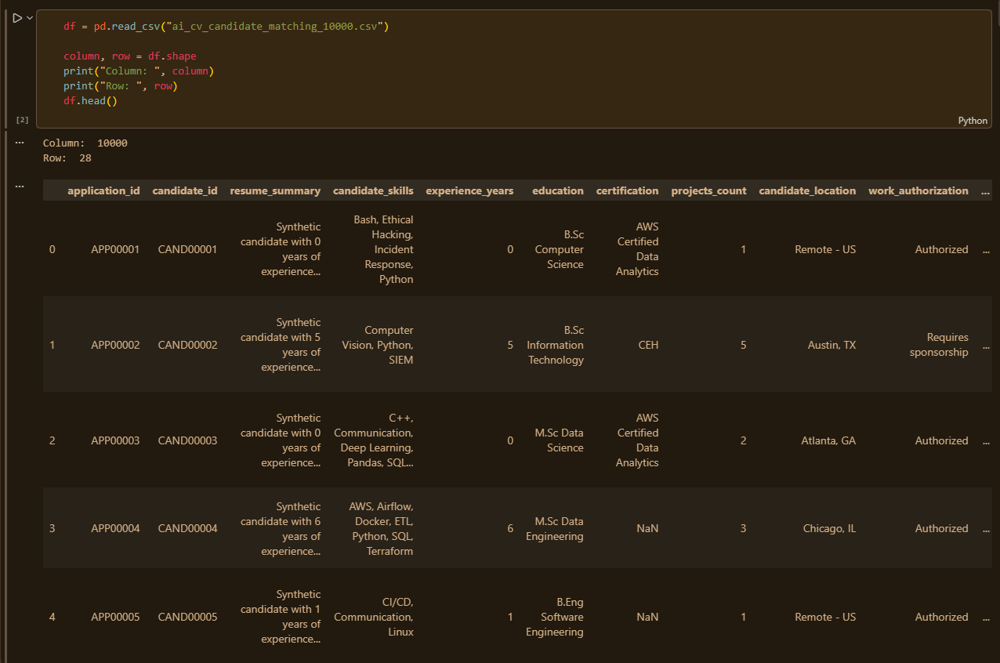
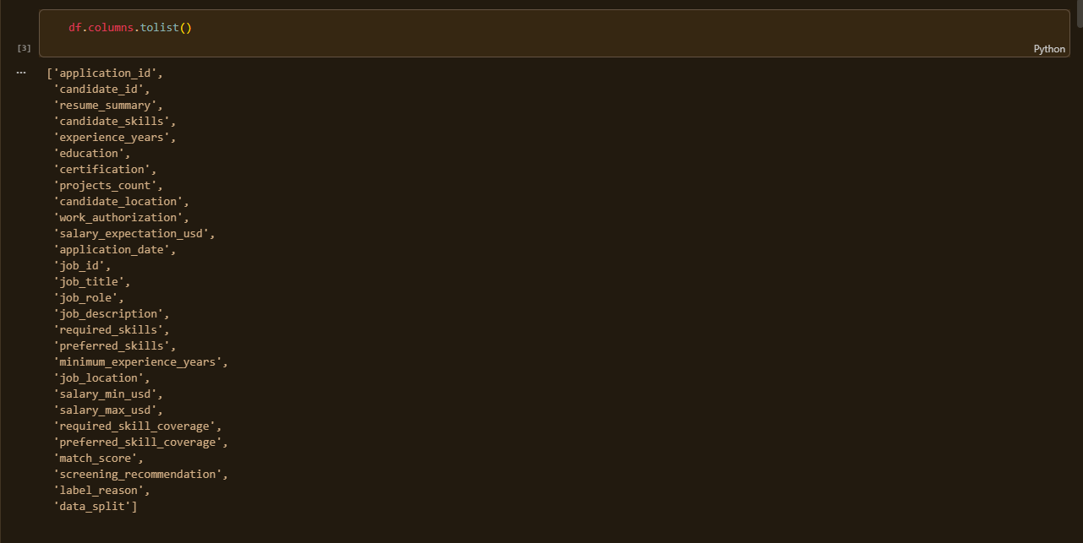
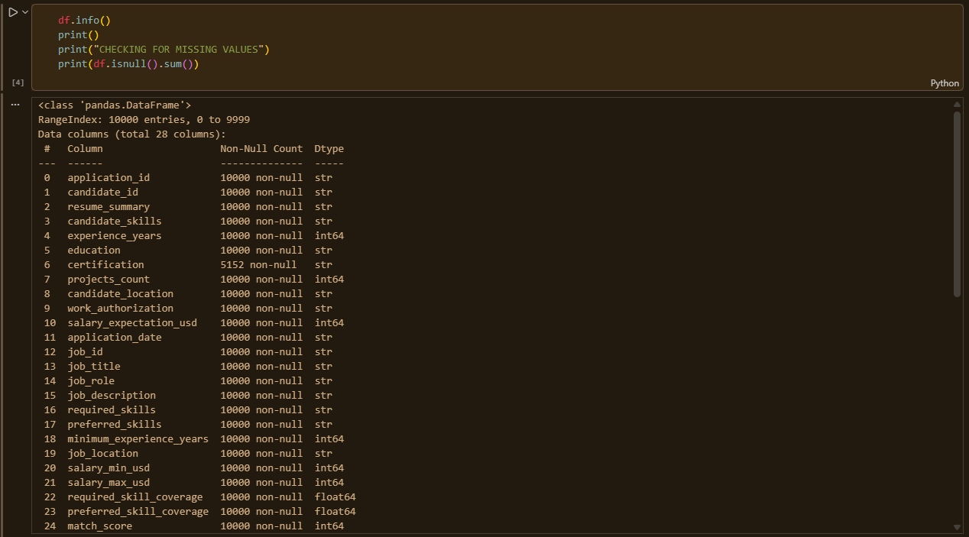

Missing Values and Duplicates
The only column with missing values is certification, with 4,848 blank entries out of 10,000. This was interpreted as “no certification held” rather than truly missing/unknown data, since it is a valid real-world state for a candidate. No duplicate rows were found in the dataset.
print("Duplicate rows:", df.duplicated().sum())
# Output: Duplicate rows: 0
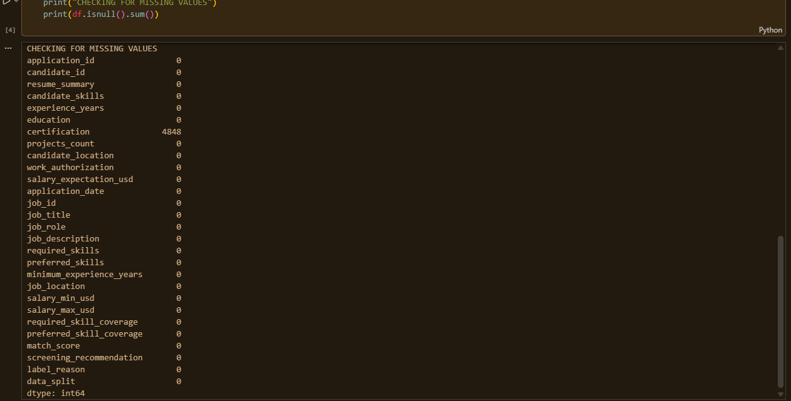

Target Variable Distribution
The target variable, screening_recommendation, has three classes. Their distribution is mildly imbalanced but not severe:
Class | Count / Percentage
Interview | 4,133 (41.33%)
Not Qualified | 3,763 (37.63%)
Manual Review | 2,104 (21.04%)
Because no class is extremely small, aggressive rebalancing techniques (e.g. SMOTE) were judged unnecessary; class_weight='balanced' was used instead during model training as a lighter-touch correction (see Section 7).
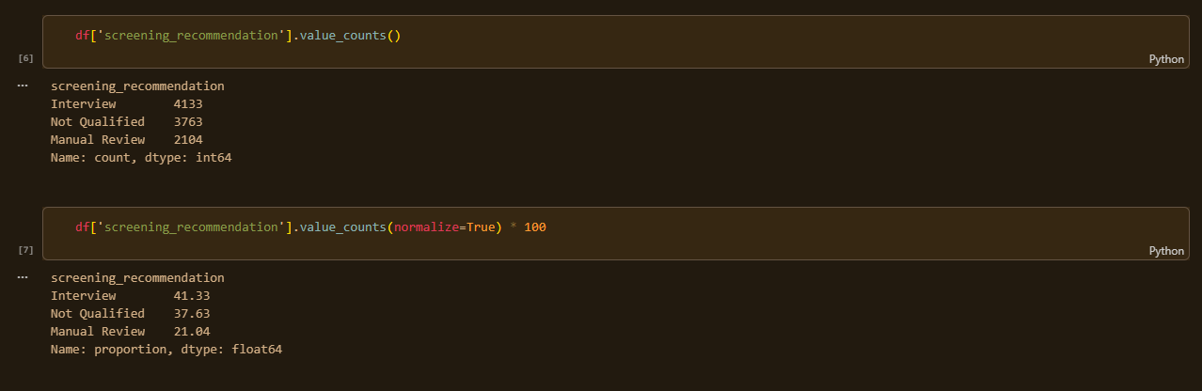

Predefined Data Split
The dataset came with a predefined data_split column dividing it into training, validation, and test partitions:
Partition | Size
Train | 7,000 records (70%)
Test | 2,000 records (20%)
Validation | 1,000 records (10%)
This predefined split was honoured rather than generating a new random split, since the dataset creator's intended partition ensures a consistent, unbiased basis for evaluation.
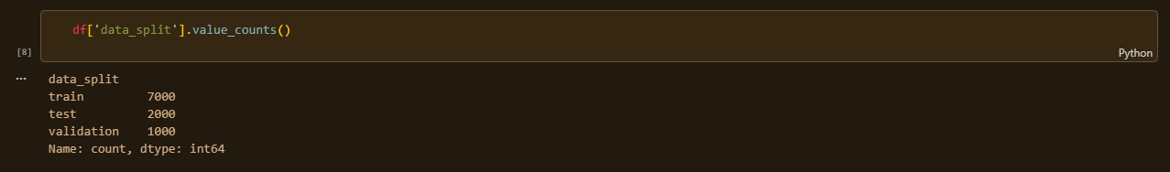

Numeric Feature Summary
Summary statistics were examined for the key numeric columns to check for irregularities such as negative values or unrealistic outliers. None were found.
Feature | Range / Mean
experience_years | 0 – 13 years (mean 3.66)
projects_count | 0 – 12 (mean 4.61)
salary_expectation_usd | $53,500 – $192,000 (mean $111,539)
minimum_experience_years | 2 – 5 years (mean 2.85)
salary_min_usd | $65,000 – $92,000
salary_max_usd | $120,000 – $163,000
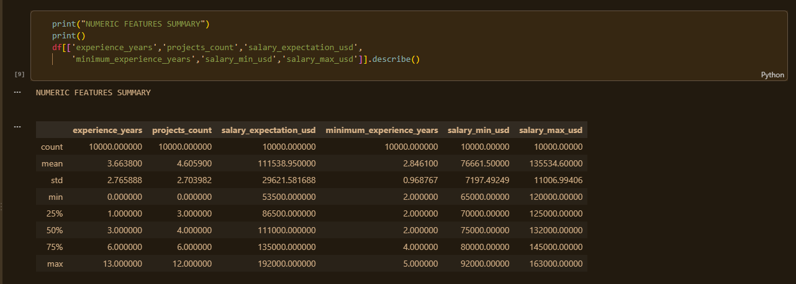

Sample Record Inspection
A single record was inspected closely to understand how candidate skills, required skills, and preferred skills relate to the generated label, before any modelling began:
CANDIDATE SKILLS: Bash, Ethical Hacking, Incident Response, Python
REQUIRED SKILLS: SQL, Python, Statistics, Machine Learning
PREFERRED SKILLS: Pandas, scikit-learn
LABEL: Not Qualified | reason: Manual review needed; missing required
skills: SQL, Statistics, Machine Learning.
This confirmed that the label logic is closely tied to how many required skills the candidate actually possesses, an important insight that later guided feature engineering.

CHAPTER 6

DATA PREPROCESSING
Having explored the dataset, several preprocessing steps were carried out to prepare it for feature engineering and modelling: handling missing values, cleaning free text, converting skill strings into structured lists, and encoding categorical variables.

Handling Missing Values
The missing certification values were filled with the literal string 'None' rather than dropped, since a blank certification field represents a real category (“no certification”), not an unknown value:
df['certification'] = df['certification'].fillna('None')

Text Cleaning
A cleaning function was written to normalize free-text fields (resume_summary and job_description) before they are passed into TF-IDF: converting text to lowercase, removing punctuation (while preserving commas, which help separate skill mentions), and collapsing extra whitespace.
def clean_text(text):
text = str(text).lower()
text = re.sub(r'[^a-z0-9\s,]', ' ', text)
text = re.sub(r'\s+', ' ', text).strip()
return text

df['resume_summary_clean'] = df['resume_summary'].apply(clean_text)
df['job_description_clean'] = df['job_description'].apply(clean_text)
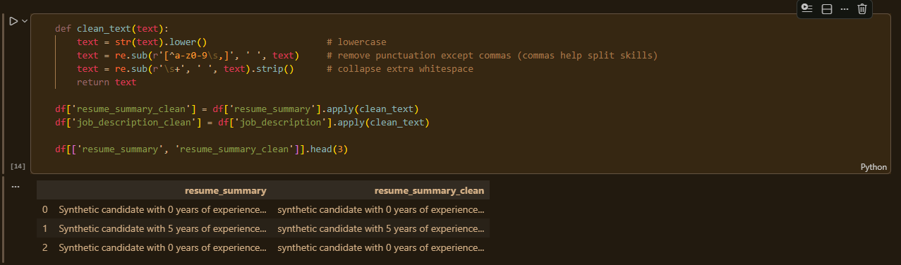

Converting Skill Strings to Lists
candidate_skills, required_skills, and preferred_skills are comma-separated strings. These were converted into clean, lower-cased Python lists so that individual skills could be compared directly using set operations:
def skills_to_list(skill_string):
return [s.strip().lower() for s in str(skill_string).split(',') if s.strip()]

df['candidate_skills_list'] = df['candidate_skills'].apply(skills_to_list)
df['required_skills_list'] = df['required_skills'].apply(skills_to_list)
df['preferred_skills_list'] = df['preferred_skills'].apply(skills_to_list)

Encoding Categorical Variables
High-cardinality location fields (candidate_location, job_location) were deliberately excluded from the model's inputs to keep the system focused on skills, experience, and qualifications rather than geography — this was also an ethical decision, to avoid the model implicitly learning any location-based bias.
The education field bundles two pieces of information — degree level (B.Sc / M.Eng / M.Sc / PhD) and field of study (e.g. Computer Science, Cybersecurity). These were split apart, since degree level has a natural order relevant to seniority, while field indicates domain relevance to the job:
def get_degree_level(edu):
edu = edu.lower()
if 'phd' in edu:
return 3
elif 'm.sc' in edu or 'm.eng' in edu:
return 2
elif 'b.sc' in edu or 'b.eng' in edu:
return 1
return 0

df['degree_level'] = df['education'].apply(get_degree_level)
df['degree_field'] = df['education'].str.replace(
r'^(B\.Sc|B\.Eng|M\.Sc|PhD)\s+', '', regex=True)
work_authorization (binary) was mapped directly to 1/0, and degree_field (16 categories) was one-hot encoded:
df['work_authorization_encoded'] = df['work_authorization'].map(
{'Authorized': 1, 'Requires sponsorship': 0})

degree_field_dummies = pd.get_dummies(df['degree_field'], prefix='field')
df = pd.concat([df, degree_field_dummies], axis=1)
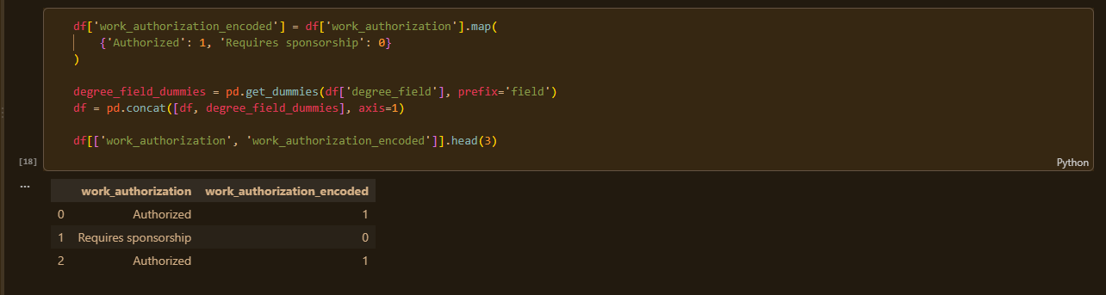

CHAPTER 7

FEATURE ENGINEERING
This is the core NLP/ML stage of the project. Three families of features were engineered: (i) skill-overlap features built from scratch using set logic, (ii) TF-IDF + cosine similarity between resume and job description text, and (iii) numeric gap features.

Skill Overlap Features
A function was written to compute, from the candidate's and job's skill lists, how many required/preferred skills are matched, how many required skills are missing, and how many “extra” skills the candidate has beyond what the job asks for:
def skill_overlap_features(candidate_skills, required_skills, preferred_skills):
cand_set = set(candidate_skills)
req_set = set(required_skills)
pref_set = set(preferred_skills)

matched_required = cand_set & req_set
matched_preferred = cand_set & pref_set

req_coverage = len(matched_required) / len(req_set) if req_set else 0
pref_coverage = len(matched_preferred) / len(pref_set) if pref_set else 0

return pd.Series({
'my_required_coverage': req_coverage,
'my_preferred_coverage': pref_coverage,
'num_required_matched': len(matched_required),
'num_required_missing': len(req_set - cand_set),
'num_extra_skills': len(cand_set - req_set - pref_set)
})
This hand-built required-skill coverage was verified against the dataset's own pre-computed required_skill_coverage column, and the two matched exactly (e.g. 0.25 vs 0.25, 0.33 vs 0.33, 1.00 vs 1.00) — confirming the logic was implemented correctly, while the dataset's own column was still excluded from the model's inputs (see Section 2.4).
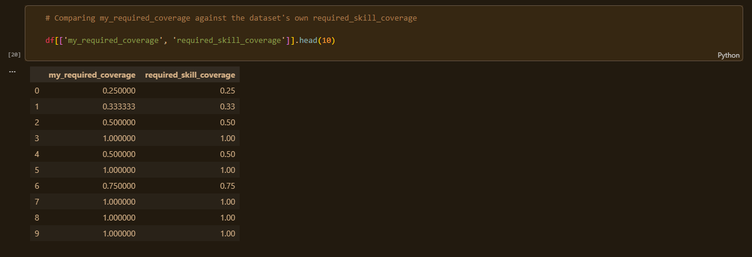

TF-IDF and Cosine Similarity
The free-text resume_summary and job_description fields were converted into numerical vectors using TF-IDF (Term Frequency-Inverse Document Frequency), and the cosine similarity between each candidate's resume vector and the corresponding job's description vector was computed row-by-row:
vectorizer = TfidfVectorizer(stop_words='english', max_features=500)

# Fit on BOTH resumes and job descriptions so they share one vocabulary
all_text = pd.concat([df['resume_summary_clean'], df['job_description_clean']])
vectorizer.fit(all_text)

resume_vectors = vectorizer.transform(df['resume_summary_clean'])
job_vectors = vectorizer.transform(df['job_description_clean'])

similarities = []
for i in range(df.shape[0]):
sim = cosine_similarity(resume_vectors[i], job_vectors[i])[0][0]
similarities.append(sim)

df['text_similarity'] = similarities
The vectorizer was fitted on both resumes and job descriptions combined so that both document types share a single vocabulary/vector space, which is what makes their cosine similarity meaningful. The resulting text_similarity values ranged from about 0.03 to 0.77, with a mean of 0.36 — a healthy, non-degenerate spread, confirming the vectors captured genuine differences between documents.
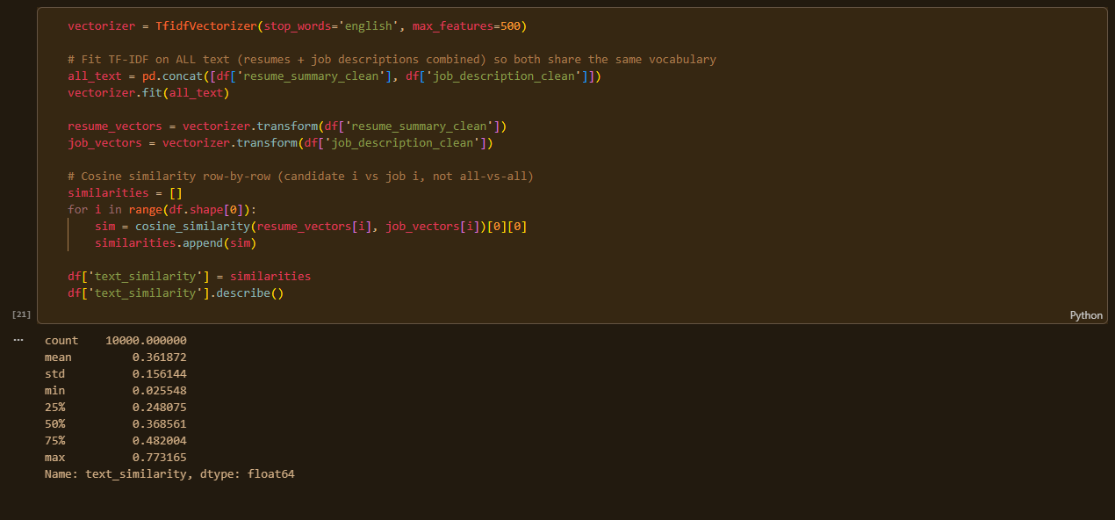

Numeric Gap Features
Two derived numeric features were added to capture realistic recruiting signals not explicit elsewhere in the data:
df['experience_gap'] = df['experience_years'] - df['minimum_experience_years']
df['salary_gap'] = df['salary_expectation_usd'] - df['salary_max_usd']
- experience_gap — positive values mean the candidate exceeds the minimum experience requirement; negative values mean they fall short.
- salary_gap — positive values mean the candidate's salary expectation exceeds the job's maximum budget, a realistic reason a recruiter might flag an application even when skills match.

CHAPTER 8

TRAIN/TEST SPLIT
The final feature table was assembled from 27 engineered and structured features (16 base features plus 11 one-hot encoded degree-field columns):
feature_cols = [
'experience_years', 'projects_count', 'salary_expectation_usd',
'minimum_experience_years', 'salary_min_usd', 'salary_max_usd',
'degree_level', 'work_authorization_encoded',
'my_required_coverage', 'my_preferred_coverage',
'num_required_matched', 'num_required_missing', 'num_extra_skills',
'text_similarity', 'experience_gap', 'salary_gap'
] + field_cols # + 11 one-hot 'field_' columns

X = df[feature_cols]
y = df['screening_recommendation']
# X.isnull().sum().sum() -> 0 (confirmed no missing values in final features)
Rather than generating a new random split, the dataset's own predefined data_split column was used to separate the data, ensuring a consistent and reproducible evaluation basis:
train_mask = df['data_split'] == 'train'
val_mask = df['data_split'] == 'validation'
test_mask = df['data_split'] == 'test'

X_train, y_train = X[train_mask], y[train_mask]
X_val, y_val = X[val_mask], y[val_mask]
X_test, y_test = X[test_mask], y[test_mask]

# Train: (7000, 27) Validation: (1000, 27) Test: (2000, 27)
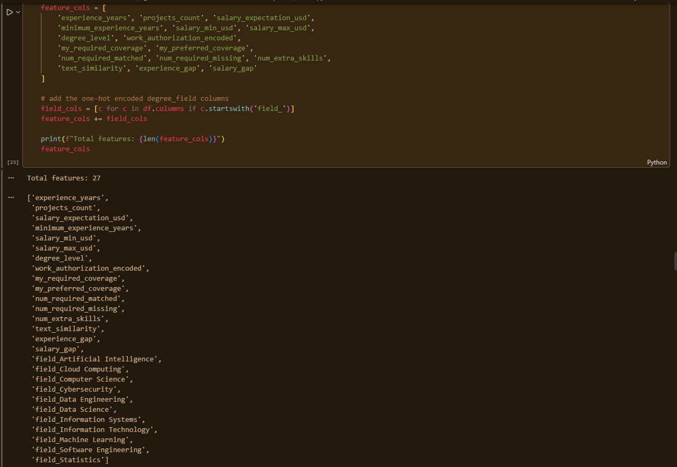

CHAPTER 9

MODEL TRAINING
A simple baseline model (Logistic Regression) was trained first, then compared against a stronger ensemble model (Random Forest), following the brief's guidance of comparing one or two reasonable models rather than an excessive number of algorithms.

Feature Scaling
Features were standardized (zero mean, unit variance) for Logistic Regression, which is sensitive to feature scale. The scaler was fitted only on the training set and then applied to the validation and test sets, to avoid data leakage (the model must never be influenced by statistics derived from data it was not trained on):
scaler = StandardScaler()
X_train_scaled = scaler.fit_transform(X_train)
X_val_scaled = scaler.transform(X_val)
X_test_scaled = scaler.transform(X_test)

Baseline Model: Logistic Regression
log_reg = LogisticRegression(max_iter=1000, class_weight='balanced', random_state=42)
log_reg.fit(X_train_scaled, y_train)
log_reg_val_preds = log_reg.predict(X_val_scaled)
class_weight='balanced' was used to correct for the mild class imbalance identified earlier (Manual Review being the smallest class at ~21%).

Comparison Model: Random Forest
rf = RandomForestClassifier(
n_estimators=200, max_depth=12, class_weight='balanced', random_state=42)
rf.fit(X_train, y_train) # tree models do not require scaled features
rf_val_preds = rf.predict(X_val)
Random Forest was trained on the unscaled feature set, since tree-based models split on raw thresholds and are unaffected by feature scale — unlike Logistic Regression, which relies on distances/weights that are sensitive to differing feature magnitudes.
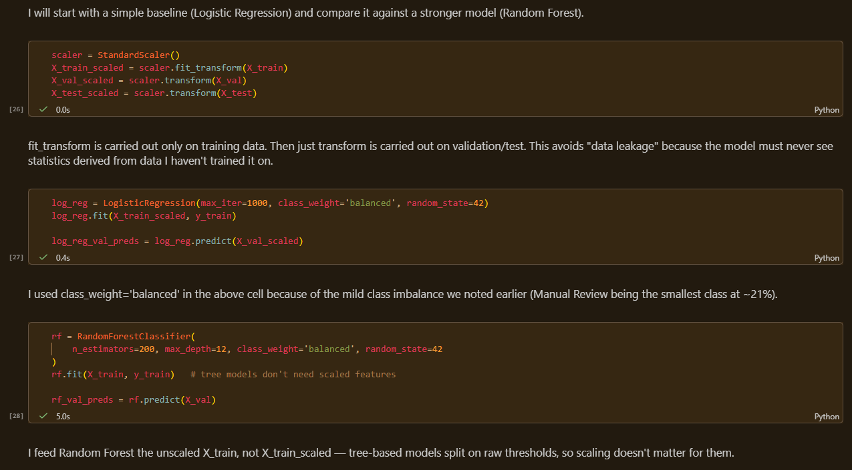

CHAPTER 10

MODEL EVALUATION
Both models were first evaluated on the validation set. Accuracy, precision, recall and F1-score were used because a screening tool must be judged not only on overall correctness but on how well it treats each class individually — a model could achieve high accuracy while performing poorly on the minority 'Manual Review' class, which would be a serious flaw for a decision-support tool.

Validation Set Results
=== Logistic Regression ===
Accuracy: 0.954
precision recall f1-score support
Interview 1.00 1.00 1.00 420
Manual Review 0.87 0.92 0.89 209
Not Qualified 0.96 0.92 0.94 371
accuracy 0.95 1000

=== Random Forest ===
Accuracy: 0.968
precision recall f1-score support
Interview 1.00 1.00 1.00 420
Manual Review 0.91 0.94 0.92 209
Not Qualified 0.97 0.95 0.96 371
accuracy 0.97 1000
Random Forest outperformed Logistic Regression on every metric, particularly on the harder Manual Review class (F1 = 0.92 vs 0.89), and was therefore selected as the final model.
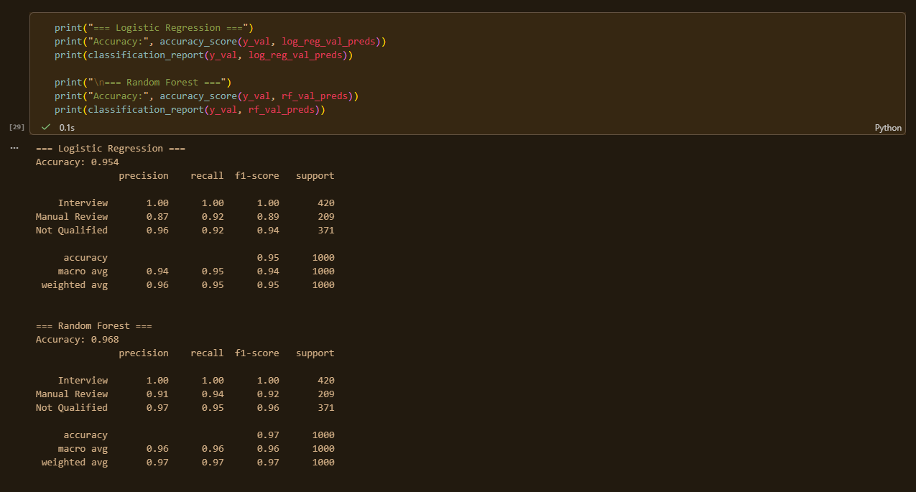

Confusion Matrices (Validation Set)
The confusion matrices below visualize where each model's predictions agreed or disagreed with the actual labels. The diagonal cells are correct predictions; off-diagonal cells show what was confused with what.
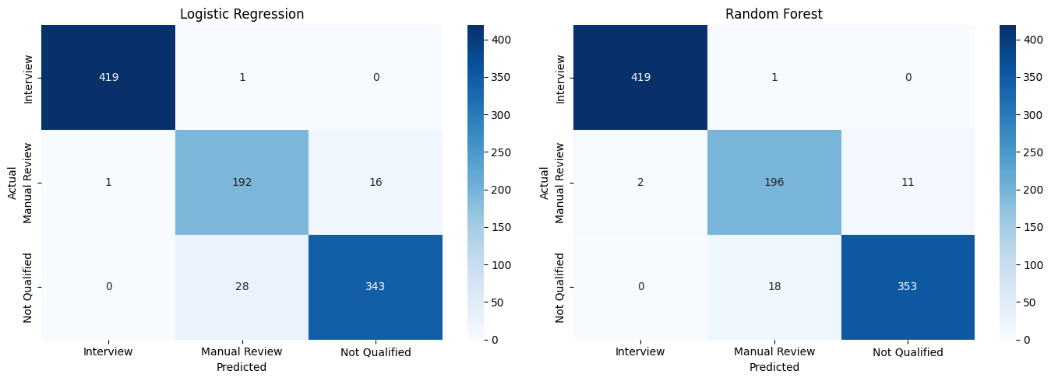
Validation-set confusion matrices — Logistic Regression (left) vs Random Forest (right)
Both models predict the Interview class almost perfectly. Random Forest makes noticeably fewer mistakes than Logistic Regression on the boundary between Manual Review and Not Qualified — the genuinely ambiguous middle ground, which is exactly where a human reviewer should also be double-checking.

Feature Importance
Random Forest's feature importances confirm that the model is driven by the same signals a human recruiter would look at, rather than spurious correlations:
Feature | Importance
my_required_coverage | 0.2477
num_required_missing | 0.1887
num_required_matched | 0.1773
my_preferred_coverage | 0.0953
experience_gap | 0.0810
experience_years | 0.0779
text_similarity | 0.0507
projects_count | 0.0307
salary_expectation_usd | 0.0099
salary_gap | 0.0094
The hand-built required-skill coverage features dominate, followed by experience-related features. The TF-IDF/cosine text_similarity feature ranks lower but still contributes meaningfully — an honest finding worth noting: structured skill-matching proved more predictive than free-text similarity alone for this dataset, which is a legitimate and defensible result rather than a weakness of the NLP component.
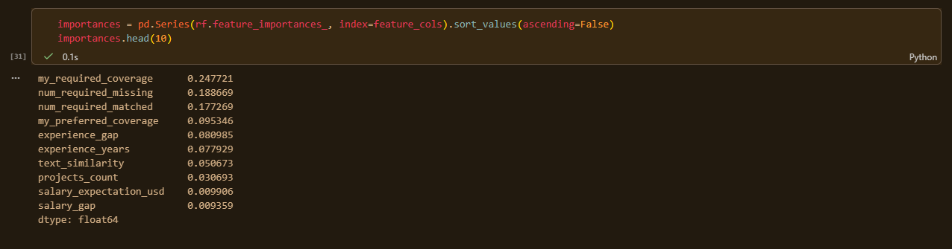

Final Test Set Evaluation
The test set was used only once, after model selection, with the winning Random Forest model:
=== Random Forest — TEST SET (final) ===
Accuracy: 0.965
precision recall f1-score support
Interview 0.99 1.00 0.99 823
Manual Review 0.92 0.91 0.91 407
Not Qualified 0.96 0.96 0.96 770
accuracy 0.96 2000
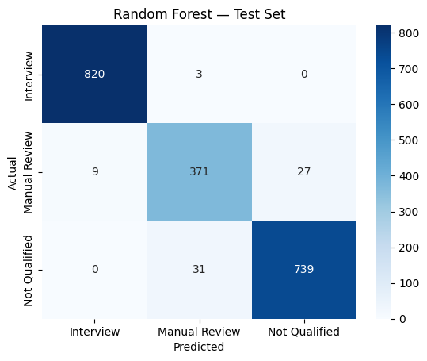
Random Forest confusion matrix on the held-out test set
The test accuracy (96.5%) closely matches the validation accuracy (96.8%), confirming the model generalizes well and was not overfit to the validation set.

A note on the high accuracy
An accuracy above 96% is unusually high for a real-world classification task. Because this dataset is synthetic and its labels were likely generated using a rule-based formula closely related to the engineered skill-coverage and experience features, the model's strong performance largely reflects how well those features approximate the label-generation rule — not necessarily how well the approach would generalize to real, noisier CVs and genuine hiring outcomes. This is stated here transparently, as it is an important, defensible limitation to raise in the project presentation.
CHAPTER 11

PREDICTION FUNCTION
A function, match_candidate(), was implemented to turn a new, raw candidate CV and job description into the human-readable screening report described in the original project brief. It repeats the exact same cleaning, skill-list conversion, TF-IDF transformation (using the already-fitted vectorizer), and feature assembly steps used during training, before calling the trained Random Forest model.
def match_candidate(candidate_skills_str, candidate_experience_years, ...
resume_summary_text, required_skills_str, ...):
# 1. Clean & structure inputs the same way as training data
# 2. Compute skill overlap features
# 3. Compute TF-IDF cosine similarity using the SAME fitted vectorizer
# 4. Compute numeric gap features
# 5. Assemble a single-row DataFrame matching the training column order
# 6. Predict class + probabilities with the trained Random Forest
# 7. Print a human-readable "AI CV SCREENING SYSTEM" report
...
return prediction, prob_dict
(See Appendix A / the accompanying notebook for the complete function implementation.)
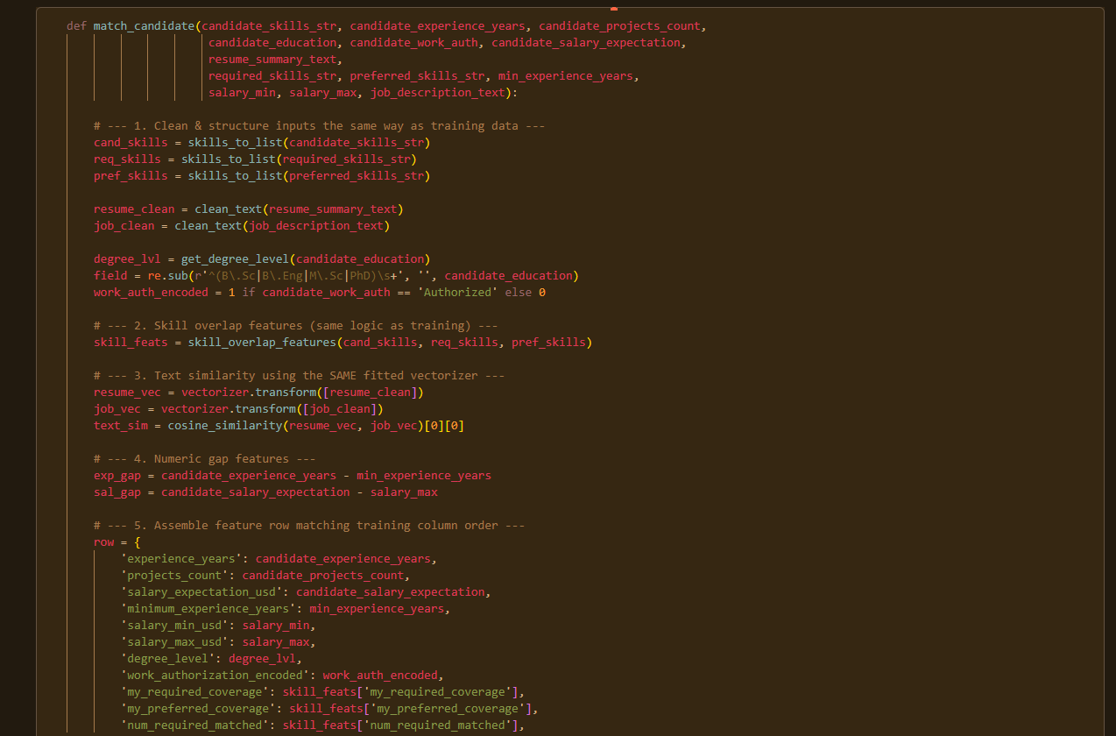
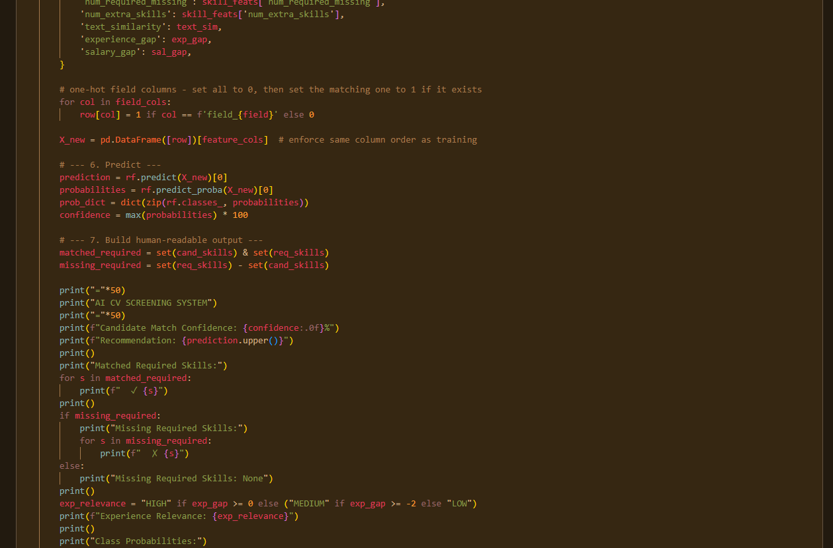
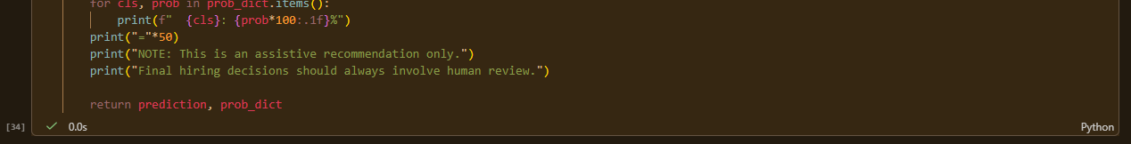

Example Run
The function was tested using an example CV modelled on the sample given in the original project brief — a candidate matching 5 of 6 required skills for a backend developer role, missing only “REST API”:
==================================================
AI CV SCREENING SYSTEM
==================================================
Candidate Match Confidence: 90%
Recommendation: MANUAL REVIEW

Matched Required Skills:
✓ django
✓ postgresql
✓ react
✓ git
✓ python

Missing Required Skills:
✗ rest api

Experience Relevance: HIGH

Class Probabilities:
Interview: 7.1%
Manual Review: 90.4%
Not Qualified: 2.6%
==================================================
NOTE: This is an assistive recommendation only.
Final hiring decisions should always involve human review.
The model correctly identified this as a strong-but-imperfect match: rather than over-confidently predicting Interview, it recognized the single missing required skill and returned Manual Review with 90.4% confidence — appropriately deferring the borderline case to a human reviewer, in line with the ethical principle.
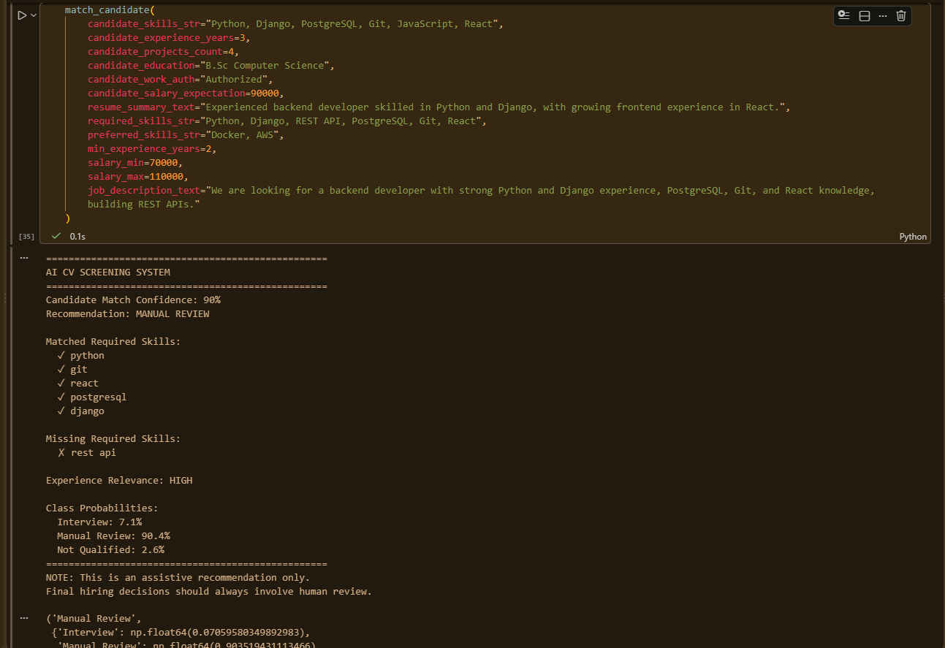

CHAPTER 12

SIMPLE USER INTERFACE
A simple Streamlit web interface (app.py) was built so the system can be demonstrated interactively without needing to run notebook cells manually. The trained model, TF-IDF vectorizer, and feature-column lists were first serialized with joblib so the app can load them without retraining:
joblib.dump(rf, 'cv_screening_model.pkl')
joblib.dump(vectorizer, 'tfidf_vectorizer.pkl')
joblib.dump(feature_cols, 'feature_cols.pkl')
joblib.dump(field_cols, 'field_cols.pkl')
The Streamlit app re-implements the same clean_text(), skills_to_list(), get_degree_level(), skill_overlap_features(), and match_candidate() logic used in the notebook, wrapped around a form-based UI. It collects the job description details and candidate CV details through input fields, and on clicking “Screen Candidate”, displays the recommendation, confidence, matched/missing skills, experience relevance, and a bar chart of class probabilities, along with the ethical disclaimer.
The interface is launched with:
streamlit run Hirely.py

Interface Screenshots
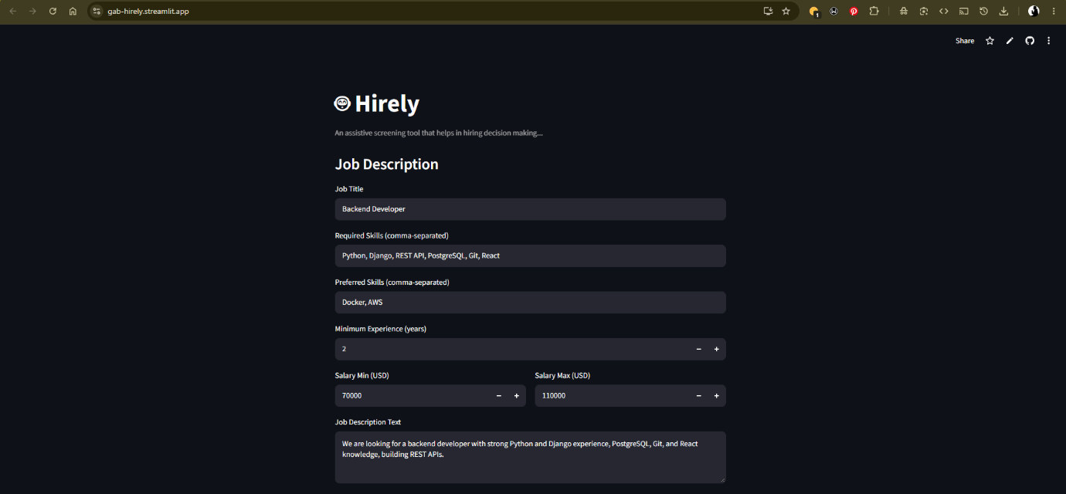
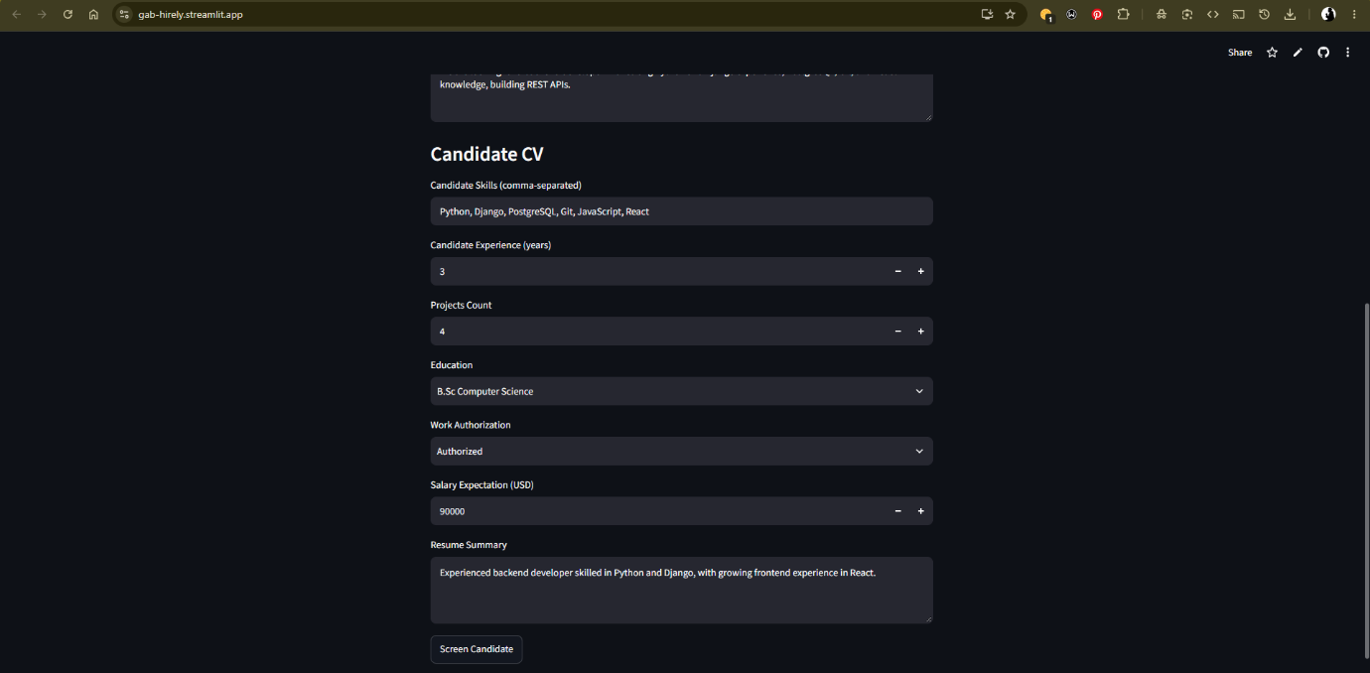
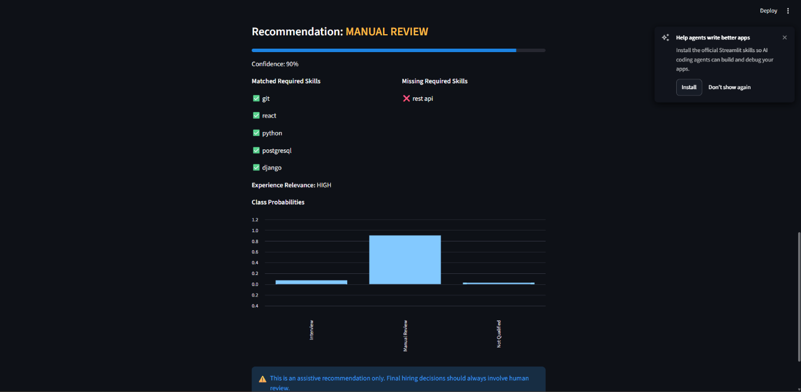

CHAPTER 13

CONCLUSION, LIMITATIONS AND RECOMMENDATIONS

Summary
This project implemented a complete AI/ML pipeline for CV screening and candidate-job matching: from raw synthetic data, through exploratory data analysis, text preprocessing, hand-built skill-overlap and TF-IDF/cosine-similarity feature engineering, to a trained and evaluated Random Forest classifier achieving 96.5% accuracy on a held-out test set, wrapped in both a reusable prediction function and a simple Streamlit interface.

Limitations
- The dataset is synthetic, with clean, consistently formatted skill lists and resume text. Real CVs are messy free text with typos, inconsistent formatting, and ambiguous skill phrasing (e.g. “worked with Python” vs. “Python (3 yrs)”), which this system was not tested against.
- The unusually high accuracy (96%+) likely reflects that the dataset's labels were generated from a rule closely related to the engineered features, rather than proof the system would generalize equally well to real-world hiring outcomes.
- Skill matching is exact-string-based after normalization; it does not currently recognize that, for example, “ML” and “Machine Learning” refer to the same skill.
- The system does not parse CVs directly from PDF/Word documents — it expects structured input fields.

Recommendations / Future Work
- Replace or augment TF-IDF with semantic sentence embeddings (e.g. Sentence-BERT) so that synonymous skills and phrasing are correctly matched.
- Add a CV-parsing component that can extract structured fields (skills, experience, education) directly from uploaded PDF/Word CVs.
- Validate the system against real, anonymized recruitment data to test whether performance holds outside the synthetic dataset.
- Add a feedback loop where recruiter overrides of the system's recommendation are logged and used to periodically retrain/improve the model.
- Extend the ethical safeguards with fairness audits across candidate demographics, once real-world data is available.

Real-World Application
This system is intended for recruiters and HR teams as a first-pass screening aid, helping them prioritize which applications to review first rather than making autonomous hiring decisions. Its main value is consistency and speed at the initial screening stage — flagging the strongest matches for interview, filtering out clear non-matches, and routing genuinely ambiguous cases to a human reviewer, exactly as demonstrated in the Manual Review example in Section 9.1.

REFERENCES

Project Links:

PATRICK GABRIEL PETER (2026). “Hirely” An AI CV Screening and Candidate Matching System

— Live Application. Streamlit Community Cloud.

Retrieved from https://gab-hirely.streamlit.app/

PATRICK GABRIEL PETER (2026). “Hirely” An AI CV Screening and Candidate Matching System

— Source Code Repository. GitHub.

Retrieved from https://github.com/GabrielBig-G/Hirely.git

Pedregosa, F., et al. (2011). Scikit-learn: Machine Learning in Python. Journal of Machine Learning Research, 12, 2825-2830.
McKinney, W. (2010). Data Structures for Statistical Computing in Python. Proceedings of the 9th Python in Science Conference.
Streamlit Inc. (2024). Streamlit Documentation. Retrieved from https://docs.streamlit.io
Manning, C. D., Raghavan, P., & Schütze, H. (2008). Introduction to Information Retrieval. Cambridge University Press. (TF-IDF and cosine similarity foundations.)
Breiman, L. (2001). Random Forests. Machine Learning, 45(1), 5-32.

APPENDIX
APPENDIX A: FULL PYTHON SOURCE CODE (JUPYTER NOTEBOOK) The complete source code for the data exploration, preprocessing, feature engineering, model training, evaluation, and prediction function developed in this project is listed below, in the order it appears in the notebook (AI_CV_SCREENING_AND_CANDIDATE_MATCHING.ipynb).

# --- Cell 1: Imports ---
import pandas as pd
import numpy as np
import re
from sklearn.feature_extraction.text import TfidfVectorizer
from sklearn.metrics.pairwise import cosine_similarity
from sklearn.preprocessing import StandardScaler
from sklearn.linear_model import LogisticRegression
from sklearn.ensemble import RandomForestClassifier
from sklearn.metrics import classification_report, confusion_matrix, accuracy_score
import matplotlib.pyplot as plt
import seaborn as sns

# --- Cell 2: Load dataset ---
df = pd.read_csv("ai_cv_candidate_matching_10000.csv")

column, row = df.shape
print("Column: ", column)
print("Row: ", row)
df.head()

# --- Cell 3: Column names ---
df.columns.tolist()

# --- Cell 4: Data types & missing values ---
df.info()
print()
print("CHECKING FOR MISSING VALUES")
print(df.isnull().sum())

# --- Cell 5: Duplicate check ---
print("Duplicate rows:", df.duplicated().sum())

# --- Cell 6: Target class counts ---
df['screening_recommendation'].value_counts()

# --- Cell 7: Target class percentages ---
df['screening_recommendation'].value_counts(normalize=True) * 100

# --- Cell 8: Predefined data split ---
df['data_split'].value_counts()

# --- Cell 9: Numeric feature summary ---
print("NUMERIC FEATURES SUMMARY")
print()
df[['experience_years','projects_count','salary_expectation_usd',
'minimum_experience_years','salary_min_usd','salary_max_usd']].describe()

# --- Cell 10: Sample record inspection ---
print("QUICK LOOK AT THE TEXT FIELDS FOR ONE ROW")
print()
row = df.iloc[0]
print("CANDIDATE SKILLS:", row['candidate_skills'])
print()
print("REQUIRED SKILLS:", row['required_skills'])
print()
print("PREFERRED SKILLS:", row['preferred_skills'])
print()
print("LABEL:", row['screening_recommendation'], "| reason:", row['label_reason'])

# --- Cell 11: Experience years sanity check ---
df.experience_years.unique()

# --- Cell 12: Salary sanity check ---
df.salary_expectation_usd.unique()

# --- Cell 13: Handle missing certification values ---
df['certification'] = df['certification'].fillna('None')
# Since missing here means "no certificate", not "unknown", it's best I fill than drop
print(df.certification.isna().sum())
print()
df.certification

# --- Cell 14: Text cleaning function ---
def clean_text(text):
text = str(text).lower() # lowercase
text = re.sub(r'[^a-z0-9\s,]', ' ', text) # remove punctuation except commas
text = re.sub(r'\s+', ' ', text).strip() # collapse extra whitespace
return text

df['resume_summary_clean'] = df['resume_summary'].apply(clean_text)
df['job_description_clean'] = df['job_description'].apply(clean_text)

df[['resume_summary', 'resume_summary_clean']].head(3)

# --- Cell 15: Convert skill strings to lists ---
def skills_to_list(skill_string):
return [s.strip().lower() for s in str(skill_string).split(',') if s.strip()]

df['candidate_skills_list'] = df['candidate_skills'].apply(skills_to_list)
df['required_skills_list'] = df['required_skills'].apply(skills_to_list)
df['preferred_skills_list'] = df['preferred_skills'].apply(skills_to_list)

df[['candidate_skills_list', 'required_skills_list', 'preferred_skills_list']].head(3)

# --- Cell 16: Inspect categorical values ---
print(df['education'].unique())
print()
print(df['work_authorization'].unique())

# --- Cell 17: Split education into degree level + field ---
def get_degree_level(edu):
edu = edu.lower()
if 'phd' in edu:
return 3
elif 'm.sc' in edu or 'm.eng' in edu:
return 2
elif 'b.sc' in edu or 'b.eng' in edu:
return 1
return 0

df['degree_level'] = df['education'].apply(get_degree_level)

# field = everything after the degree abbreviation
df['degree_field'] = df['education'].str.replace(
r'^(B\.Sc|B\.Eng|M\.Sc|PhD)\s+', '', regex=True
)

df[['education', 'degree_level', 'degree_field']].head(5)

# --- Cell 18: Encode work_authorization & one-hot degree_field ---
df['work_authorization_encoded'] = df['work_authorization'].map(
{'Authorized': 1, 'Requires sponsorship': 0}
)

degree_field_dummies = pd.get_dummies(df['degree_field'], prefix='field')
df = pd.concat([df, degree_field_dummies], axis=1)

df[['work_authorization', 'work_authorization_encoded']].head(3)

# --- Cell 19: Skill overlap features ---
def skill_overlap_features(candidate_skills, required_skills, preferred_skills):
cand_set = set(candidate_skills)
req_set = set(required_skills)
pref_set = set(preferred_skills)

matched_required = cand_set & req_set
matched_preferred = cand_set & pref_set

req_coverage = len(matched_required) / len(req_set) if req_set else 0
pref_coverage = len(matched_preferred) / len(pref_set) if pref_set else 0

return pd.Series({
'my_required_coverage': req_coverage,
'my_preferred_coverage': pref_coverage,
'num_required_matched': len(matched_required),
'num_required_missing': len(req_set - cand_set),
'num_extra_skills': len(cand_set - req_set - pref_set)
})

skill_features = df.apply(
lambda row: skill_overlap_features(
row['candidate_skills_list'],
row['required_skills_list'],
row['preferred_skills_list']
), axis=1
)

df = pd.concat([df, skill_features], axis=1)
df[['my_required_coverage', 'my_preferred_coverage',
'num_required_matched', 'num_required_missing']].head(5)

# --- Cell 20: Verify against dataset's own coverage column ---
df[['my_required_coverage', 'required_skill_coverage']].head(10)

# --- Cell 21: TF-IDF + cosine similarity ---
vectorizer = TfidfVectorizer(stop_words='english', max_features=500)

# Fit TF-IDF on ALL text (resumes + job descriptions) so both share one vocabulary
all_text = pd.concat([df['resume_summary_clean'], df['job_description_clean']])
vectorizer.fit(all_text)

resume_vectors = vectorizer.transform(df['resume_summary_clean'])
job_vectors = vectorizer.transform(df['job_description_clean'])

# Cosine similarity row-by-row (candidate i vs job i, not all-vs-all)
similarities = []
for i in range(df.shape[0]):
sim = cosine_similarity(resume_vectors[i], job_vectors[i])[0][0]
similarities.append(sim)

df['text_similarity'] = similarities
df['text_similarity'].describe()

# --- Cell 22: Numeric gap features ---
df['experience_gap'] = df['experience_years'] - df['minimum_experience_years']
df['salary_gap'] = df['salary_expectation_usd'] - df['salary_max_usd']

# --- Cell 23: Final feature list ---
feature_cols = [
'experience_years', 'projects_count', 'salary_expectation_usd',
'minimum_experience_years', 'salary_min_usd', 'salary_max_usd',
'degree_level', 'work_authorization_encoded',
'my_required_coverage', 'my_preferred_coverage',
'num_required_matched', 'num_required_missing', 'num_extra_skills',
'text_similarity', 'experience_gap', 'salary_gap'
]

field_cols = [c for c in df.columns if c.startswith('field_')]
feature_cols += field_cols

print(f"Total features: {len(feature_cols)}")
feature_cols

# --- Cell 24: Build X, y ---
X = df[feature_cols]
y = df['screening_recommendation']

X.isnull().sum().sum()
# x being the feature while y is the target

# --- Cell 25: Train/validation/test split (predefined) ---
train_mask = df['data_split'] == 'train'
val_mask = df['data_split'] == 'validation'
test_mask = df['data_split'] == 'test'

X_train, y_train = X[train_mask], y[train_mask]
X_val, y_val = X[val_mask], y[val_mask]
X_test, y_test = X[test_mask], y[test_mask]

print("Train:", X_train.shape, "Validation:", X_val.shape, "Test:", X_test.shape)

# --- Cell 26: Feature scaling ---
scaler = StandardScaler()
X_train_scaled = scaler.fit_transform(X_train)
X_val_scaled = scaler.transform(X_val)
X_test_scaled = scaler.transform(X_test)

# --- Cell 27: Logistic Regression (baseline) ---
log_reg = LogisticRegression(max_iter=1000, class_weight='balanced', random_state=42)
log_reg.fit(X_train_scaled, y_train)

log_reg_val_preds = log_reg.predict(X_val_scaled)

# --- Cell 28: Random Forest ---
rf = RandomForestClassifier(
n_estimators=200, max_depth=12, class_weight='balanced', random_state=42
)
rf.fit(X_train, y_train) # tree models don't need scaled features

rf_val_preds = rf.predict(X_val)

# --- Cell 29: Validation evaluation ---
print("=== Logistic Regression ===")
print("Accuracy:", accuracy_score(y_val, log_reg_val_preds))
print(classification_report(y_val, log_reg_val_preds))

print("\n=== Random Forest ===")
print("Accuracy:", accuracy_score(y_val, rf_val_preds))
print(classification_report(y_val, rf_val_preds))

# --- Cell 30: Confusion matrices (validation) ---
labels = ['Interview', 'Manual Review', 'Not Qualified']

fig, axes = plt.subplots(1, 2, figsize=(14, 5))

cm_lr = confusion_matrix(y_val, log_reg_val_preds, labels=labels)
sns.heatmap(cm_lr, annot=True, fmt='d', cmap='Blues',
xticklabels=labels, yticklabels=labels, ax=axes[0])
axes[0].set_title('Logistic Regression')
axes[0].set_xlabel('Predicted')
axes[0].set_ylabel('Actual')

cm_rf = confusion_matrix(y_val, rf_val_preds, labels=labels)
sns.heatmap(cm_rf, annot=True, fmt='d', cmap='Blues',
xticklabels=labels, yticklabels=labels, ax=axes[1])
axes[1].set_title('Random Forest')
axes[1].set_xlabel('Predicted')
axes[1].set_ylabel('Actual')

plt.tight_layout()
plt.show()

# --- Cell 31: Feature importance ---
importances = pd.Series(rf.feature_importances_, index=feature_cols).sort_values(ascending=False)
importances.head(10)

# --- Cell 32: Final test set evaluation ---
rf_test_preds = rf.predict(X_test)

print("=== Random Forest — TEST SET (final) ===")
print("Accuracy:", accuracy_score(y_test, rf_test_preds))
print(classification_report(y_test, rf_test_preds))

# --- Cell 33: Confusion matrix (test) ---
cm_test = confusion_matrix(y_test, rf_test_preds, labels=labels)
sns.heatmap(cm_test, annot=True, fmt='d', cmap='Blues', xticklabels=labels, yticklabels=labels)
plt.title('Random Forest — Test Set')
plt.xlabel('Predicted')
plt.ylabel('Actual')
plt.show()

# --- Cell 34: Prediction function ---
def match_candidate(candidate_skills_str, candidate_experience_years, candidate_projects_count,
candidate_education, candidate_work_auth, candidate_salary_expectation,
resume_summary_text,
required_skills_str, preferred_skills_str, min_experience_years,
salary_min, salary_max, job_description_text):

# 1. Clean & structure inputs the same way as training data
cand_skills = skills_to_list(candidate_skills_str)
req_skills = skills_to_list(required_skills_str)
pref_skills = skills_to_list(preferred_skills_str)

resume_clean = clean_text(resume_summary_text)
job_clean = clean_text(job_description_text)

degree_lvl = get_degree_level(candidate_education)
field = re.sub(r'^(B\.Sc|B\.Eng|M\.Sc|PhD)\s+', '', candidate_education)
work_auth_encoded = 1 if candidate_work_auth == 'Authorized' else 0

# 2. Skill overlap features (same logic as training)
skill_feats = skill_overlap_features(cand_skills, req_skills, pref_skills)

# 3. Text similarity using the SAME fitted vectorizer
resume_vec = vectorizer.transform([resume_clean])
job_vec = vectorizer.transform([job_clean])
text_sim = cosine_similarity(resume_vec, job_vec)[0][0]

# 4. Numeric gap features
exp_gap = candidate_experience_years - min_experience_years
sal_gap = candidate_salary_expectation - salary_max

# 5. Assemble feature row matching training column order
row = {
'experience_years': candidate_experience_years,
'projects_count': candidate_projects_count,
'salary_expectation_usd': candidate_salary_expectation,
'minimum_experience_years': min_experience_years,
'salary_min_usd': salary_min,
'salary_max_usd': salary_max,
'degree_level': degree_lvl,
'work_authorization_encoded': work_auth_encoded,
'my_required_coverage': skill_feats['my_required_coverage'],
'my_preferred_coverage': skill_feats['my_preferred_coverage'],
'num_required_matched': skill_feats['num_required_matched'],
'num_required_missing': skill_feats['num_required_missing'],
'num_extra_skills': skill_feats['num_extra_skills'],
'text_similarity': text_sim,
'experience_gap': exp_gap,
'salary_gap': sal_gap,
}

for col in field_cols:
row[col] = 1 if col == f'field_{field}' else 0

X_new = pd.DataFrame([row])[feature_cols] # enforce same column order as training

# 6. Predict
prediction = rf.predict(X_new)[0]
probabilities = rf.predict_proba(X_new)[0]
prob_dict = dict(zip(rf.classes_, probabilities))
confidence = max(probabilities) * 100

# 7. Build human-readable output
matched_required = set(cand_skills) & set(req_skills)
missing_required = set(req_skills) - set(cand_skills)

print("="*50)
print("AI CV SCREENING SYSTEM")
print("="*50)
print(f"Candidate Match Confidence: {confidence:.0f}%")
print(f"Recommendation: {prediction.upper()}")
print()
print("Matched Required Skills:")
for s in matched_required:
print(f" ✓ {s}")
print()
if missing_required:
print("Missing Required Skills:")
for s in missing_required:
print(f" ✗ {s}")
else:
print("Missing Required Skills: None")
print()
exp_relevance = "HIGH" if exp_gap >= 0 else ("MEDIUM" if exp_gap >= -2 else "LOW")
print(f"Experience Relevance: {exp_relevance}")
print()
print("Class Probabilities:")
for cls, prob in prob_dict.items():
print(f" {cls}: {prob*100:.1f}%")
print("="*50)
print("NOTE: This is an assistive recommendation only.")
print("Final hiring decisions should always involve human review.")

return prediction, prob_dict

# --- Cell 35: Example run ---
match_candidate(
candidate_skills_str="Python, Django, PostgreSQL, Git, JavaScript, React",
candidate_experience_years=3,
candidate_projects_count=4,
candidate_education="B.Sc Computer Science",
candidate_work_auth="Authorized",
candidate_salary_expectation=90000,
resume_summary_text="Experienced backend developer skilled in Python and Django, with growing frontend experience in React.",
required_skills_str="Python, Django, REST API, PostgreSQL, Git, React",
preferred_skills_str="Docker, AWS",
min_experience_years=2,
salary_min=70000,
salary_max=110000,
job_description_text="We are looking for a backend developer with strong Python and Django experience, PostgreSQL, Git, and React knowledge, building REST APIs."
)

# --- Cell 36: Save model artifacts for deployment ---
import joblib

joblib.dump(rf, 'cv_screening_model.pkl')
joblib.dump(vectorizer, 'tfidf_vectorizer.pkl')
joblib.dump(feature_cols, 'feature_cols.pkl')
joblib.dump(field_cols, 'field_cols.pkl')

print("Model artifacts saved.")

APPENDIX B: STREAMLIT APPLICATION SOURCE CODE (Hirely.py)
The code below implements the simple user interface, wrapping the trained model in an interactive web form.

import streamlit as st
import pandas as pd
import numpy as np
import re
import joblib
from sklearn.metrics.pairwise import cosine_similarity

# --- Load saved artifacts ---
rf = joblib.load('cv_screening_model.pkl')
vectorizer = joblib.load('tfidf_vectorizer.pkl')
feature_cols = joblib.load('feature_cols.pkl')
field_cols = joblib.load('field_cols.pkl')

# --- Helper functions (same as notebook) ---
def clean_text(text):
text = str(text).lower()
text = re.sub(r'[^a-z0-9\s,]', ' ', text)
text = re.sub(r'\s+', ' ', text).strip()
return text

def skills_to_list(skill_string):
return [s.strip().lower() for s in str(skill_string).split(',') if s.strip()]

def get_degree_level(edu):
edu = edu.lower()
if 'phd' in edu:
return 3
elif 'm.sc' in edu or 'm.eng' in edu:
return 2
elif 'b.sc' in edu or 'b.eng' in edu:
return 1
return 0

def skill_overlap_features(candidate_skills, required_skills, preferred_skills):
cand_set = set(candidate_skills)
req_set = set(required_skills)
pref_set = set(preferred_skills)
matched_required = cand_set & req_set
matched_preferred = cand_set & pref_set
req_coverage = len(matched_required) / len(req_set) if req_set else 0
pref_coverage = len(matched_preferred) / len(pref_set) if pref_set else 0
return {
'my_required_coverage': req_coverage,
'my_preferred_coverage': pref_coverage,
'num_required_matched': len(matched_required),
'num_required_missing': len(req_set - cand_set),
'num_extra_skills': len(cand_set - req_set - pref_set)
}

def match_candidate(candidate_skills_str, candidate_experience_years, candidate_projects_count,
candidate_education, candidate_work_auth, candidate_salary_expectation,
resume_summary_text, required_skills_str, preferred_skills_str,
min_experience_years, salary_min, salary_max, job_description_text):

cand_skills = skills_to_list(candidate_skills_str)
req_skills = skills_to_list(required_skills_str)
pref_skills = skills_to_list(preferred_skills_str)

resume_clean = clean_text(resume_summary_text)
job_clean = clean_text(job_description_text)

degree_lvl = get_degree_level(candidate_education)
field = re.sub(r'^(B\.Sc|B\.Eng|M\.Sc|PhD)\s+', '', candidate_education)
work_auth_encoded = 1 if candidate_work_auth == 'Authorized' else 0

skill_feats = skill_overlap_features(cand_skills, req_skills, pref_skills)

resume_vec = vectorizer.transform([resume_clean])
job_vec = vectorizer.transform([job_clean])
text_sim = cosine_similarity(resume_vec, job_vec)[0][0]

exp_gap = candidate_experience_years - min_experience_years
sal_gap = candidate_salary_expectation - salary_max

row = {
'experience_years': candidate_experience_years,
'projects_count': candidate_projects_count,
'salary_expectation_usd': candidate_salary_expectation,
'minimum_experience_years': min_experience_years,
'salary_min_usd': salary_min,
'salary_max_usd': salary_max,
'degree_level': degree_lvl,
'work_authorization_encoded': work_auth_encoded,
'my_required_coverage': skill_feats['my_required_coverage'],
'my_preferred_coverage': skill_feats['my_preferred_coverage'],
'num_required_matched': skill_feats['num_required_matched'],
'num_required_missing': skill_feats['num_required_missing'],
'num_extra_skills': skill_feats['num_extra_skills'],
'text_similarity': text_sim,
'experience_gap': exp_gap,
'salary_gap': sal_gap,
}
for col in field_cols:
row[col] = 1 if col == f'field_{field}' else 0

X_new = pd.DataFrame([row])[feature_cols]
prediction = rf.predict(X_new)[0]
probabilities = rf.predict_proba(X_new)[0]
prob_dict = dict(zip(rf.classes_, probabilities))
confidence = max(probabilities) * 100

matched_required = set(cand_skills) & set(req_skills)
missing_required = set(req_skills) - set(cand_skills)
exp_relevance = "HIGH" if exp_gap >= 0 else ("MEDIUM" if exp_gap >= -2 else "LOW")

return {
'prediction': prediction,
'confidence': confidence,
'prob_dict': prob_dict,
'matched_required': matched_required,
'missing_required': missing_required,
'exp_relevance': exp_relevance
}

# --- Streamlit UI ---
st.set_page_config(page_title="AI CV Screening System", layout="centered")
st.title("🤖 Hirely")
st.caption("An assistive screening tool that helps in hiring decision making…”)

st.subheader("Job Description")
job_title = st.text_input("Job Title", "Backend Developer")
required_skills_str = st.text_input("Required Skills (comma-separated)", "Python, Django, REST API, PostgreSQL, Git, React")
preferred_skills_str = st.text_input("Preferred Skills (comma-separated)", "Docker, AWS")
min_experience_years = st.number_input("Minimum Experience (years)", min_value=0, value=2)
col1, col2 = st.columns(2)
salary_min = col1.number_input("Salary Min (USD)", min_value=0, value=70000)
salary_max = col2.number_input("Salary Max (USD)", min_value=0, value=110000)
job_description_text = st.text_area("Job Description Text",
"We are looking for a backend developer with strong Python and Django experience, PostgreSQL, Git, and React knowledge, building REST APIs.")

st.subheader("Candidate CV")
candidate_skills_str = st.text_input("Candidate Skills (comma-separated)", "Python, Django, PostgreSQL, Git, JavaScript, React")
candidate_experience_years = st.number_input("Candidate Experience (years)", min_value=0, value=3)
candidate_projects_count = st.number_input("Projects Count", min_value=0, value=4)
candidate_education = st.selectbox("Education", [
'B.Sc Computer Science', 'B.Sc Information Technology', 'M.Sc Data Science',
'M.Sc Data Engineering', 'B.Eng Software Engineering', 'PhD Statistics',
'PhD Computer Science', 'B.Sc Statistics', 'B.Sc Information Systems',
'M.Sc Cloud Computing', 'M.Sc Artificial Intelligence', 'M.Sc Cybersecurity',
'M.Sc Machine Learning', 'B.Eng Information Technology', 'M.Sc Computer Science',
'B.Sc Cybersecurity'
])
candidate_work_auth = st.selectbox("Work Authorization", ["Authorized", "Requires sponsorship"])
candidate_salary_expectation = st.number_input("Salary Expectation (USD)", min_value=0, value=90000)
resume_summary_text = st.text_area("Resume Summary",
"Experienced backend developer skilled in Python and Django, with growing frontend experience in React.")

if st.button("Screen Candidate"):
result = match_candidate(
candidate_skills_str, candidate_experience_years, candidate_projects_count,
candidate_education, candidate_work_auth, candidate_salary_expectation,
resume_summary_text, required_skills_str, preferred_skills_str,
min_experience_years, salary_min, salary_max, job_description_text
)

st.divider()
st.subheader("Result")
rec = result['prediction']
color = {"Interview": "green", "Manual Review": "orange", "Not Qualified": "red"}[rec]
st.markdown(f"### Recommendation: :{color}[{rec.upper()}]")
st.progress(int(result['confidence']))
st.write(f"Confidence: {result['confidence']:.0f}%")

col1, col2 = st.columns(2)
with col1:
st.write("**Matched Required Skills**")
for s in result['matched_required']:
st.write(f"✅ {s}")
with col2:
st.write("**Missing Required Skills**")
if result['missing_required']:
for s in result['missing_required']:
st.write(f"❌ {s}")
else:
st.write("None")

st.write(f"**Experience Relevance:** {result['exp_relevance']}")

st.write("**Class Probabilities**")
st.bar_chart(pd.Series(result['prob_dict']))

st.info("⚠️ This is an assistive recommendation only. Final hiring decisions should always involve human review.")

APPENDIX C: REQUIREMENTS.TXT (DEPLOYMENT DEPENDENCIES)
streamlit
pandas
numpy
scikit-learn
joblib

APPENDIX D: SAMPLE SYSTEM OUTPUT
The output below is an actual run of match_candidate() using a test
candidate modelled on the example given in the original project brief.

==================================================
AI CV SCREENING SYSTEM
==================================================
Candidate Match Confidence: 90%
Recommendation: MANUAL REVIEW

Matched Required Skills:
✓ django
✓ postgresql
✓ react
✓ git
✓ python

Missing Required Skills:
✗ rest api

Experience Relevance: HIGH

Class Probabilities:
Interview: 7.1%
Manual Review: 90.4%
Not Qualified: 2.6%
==================================================
NOTE: This is an assistive recommendation only.
Final hiring decisions should always involve human review.

